## ADV JAV...... NAT 205

## ADV JAVA NEW 179

## ADV JAVA SEKHAR 123

## ADVANCEJAVA BY SEKAR 205

## JEE Complete 86

## kvr-adv-1- 42

## NEW ADV SATHYA shekar 141

## NV JAVA 100

## Z ADVance Java 41

## Servlets

**Syllabus:**

**The Servlet Technology Models**

* HTTP Methods
* Servlet Life Cycle
* Servlet Request
* Servlet Response

**Web Application folder structure and deployment descriptor**

* Application folder structure
* Web.xml
* War file

**Web Container Model**

* Servlet Context and context parameter
* Servlet scopes and attributes
* Request Dispatcher
* Filters
* Wrappers

**Session Management**

* Session API
* Cookies
* URL Rewriting
* Hidden form fields
* Listeners

**Web Security**

* Basic Terminology
* Types of Authentication
* Declarative Security
* Programmatic Security

**JSPs**

**These are the part of Java Enterprise Edition (J2EE/JEE)**

**Current Versions:**

**JSE 8.0**

JDBC Version – 4.2

**JEE7**

Servlets – 3.1v

JSP - 2.3v

JSTL-1.2v

EL (Expression Logic)-3.0v

**Introduction**

In general by using Java technology we are able to design following 2 types of applications.

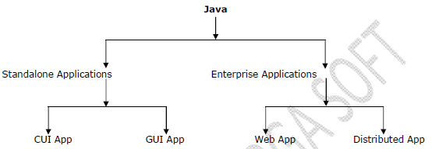

**1. Standalone Applications:**

These are the java applications, which will be designed without using Client-Server Architecture.

There are 2 types of Standalone applications.

**1. CUI Applications**

**2. GUI Applications**

**Q: What are the differences between CUI Applications and GUI Applications?**

**Ans:**CUI Applications are the standalone applications, which will be designed in such a way to take input and to provide output by using Command prompt, where Command prompt is acting as user interface and it able to support character data. So that the java application which will design on the basis of command prompt i.e. character user interface is called as **CUI application**.

GUI Applications are the standalone applications, which will be designed in such a way to take input and to provide output by using a collection of Graphic component, where the collection of Graphic components is acting as an user interface and it able to support GUI component so that the java application which will be design on the basis of Graphical user interface is called as **GUI Application**.

**2. Enterprise Applications:**

These are the java applications, which will be designed on the basis of ***Client-Server*** Architecture.

There are 2 types of Enterprise applications.

**1. Web Applications**

**2. Distributed Applications**

**Q: What are the differences between Web Applications and Distributed Applications?**

**Ans:**

1. Web Application is the server side application; it will be designed **without disturbing its application logic** over multiple numbers of JVM’s.

Distributed application is the server side application it will be designed **by disturbing application logic over** **multiple** numbers of JVM’s.

2. In general web applications will be designed by using a set of server side technologies called as Web technologies like CGI, Servlets, JSP’s and so on.

Distributed applications will be designed by using a set of technologies called as Distributed technologies like Socket programming, RMI, EJB’s, Web services and so on.

3. The main purpose of web applications is to **generate dynamic response from server machine**, but the main purpose of distributed applications is to establish distributed **communication between local machine and remote machine** in order to access the remote services.

4. In general web applications will provide services for web clients, but distributed applications will provide services for any type of clients.

5. In general web applications will be executed by using both web servers and application servers, but distributed applications will be executed by using only application servers.

**1. Web Applications:**

Web Application is a collection of web components; it will be executed by using web containers like Servlet Container to execute servlets, Jsp Container to execute JSP’s and so on.

**2. Distributed Applications:**

Distributed Application is a collection of distributed components; it will be executed by using the distributed containers like EJB’s Container to execute EJB’s.

At the beginning stages of the computer we have Client-Server architecture, where the purpose of server is to hold up some resources and to share those resources to all the clients as per the client request.

In the above context, when we send a request from client to server for a particular resource then server will identify requested resource, pick up the content and send that content as response to client without performing any particular action at server. In this case the response which was generated by server is called as **static response**.

As per the application requirements, we need to generate dynamic response from server, for this we need to execute the application at server called as **Web Application**. To design web applications at server side we need a set of server side technologies called as **Web Technologies.**

To design web applications we will use web technologies like CGI, Servlets, Jsp’s, Perl, PHP and so on. Therefore, the main purpose of servlets and jsp’s is to design web applications at server in order to generate dynamic response from server.

**Q: To design web applications at server we have already CGI Technology then what is the requirement to go for servlets?**

**Ans:**

**CGI** is the **server side technology** designed on the basis of C technology and Scripting. C technology is the process based technology; it will make CGI technology as **process based technology**.

If we deploy any CGI application at server side then container will create a separate process for each and every request. If we increase number of requests automatically CGI container will generate number of processes at server.

Basically process is a heavy weight component; to handle single process system has to consume a lot of system memory and execution time.

Due to the above reason to handle the multiple numbers of processes at a time server machine may get burden, due to this reason server may generate delayed responses to the client request, it will reduce the performance of server side application.

In the above context, to increase the performance of the server side application we have to use an alternative server side technology i.e. Servlets.

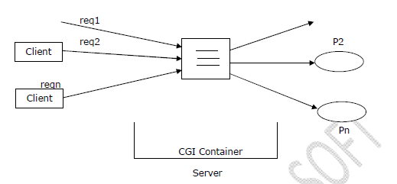

**Servlet** is the **server side technology** designed on the basis of java technology. Java technology is a Thread based technology; it will make servlets as **Thread based technologies.**

If we deploy any servlet application at server then for every client request servlet container will generate a separate thread on the respective servlet object.

In the above context, if we increase number of requests even container will create number of threads instead of processes.

When compared to process thread is light weight, to handle multiple number of requests i.e. thread server machine may not get burden, it may provide quick responses for the client request, it may increase the performance of server side application.

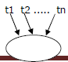

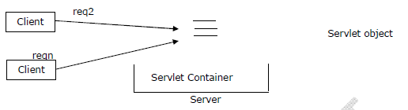

**Q: What are the differences between servlets and jsps?**

**Ans:**

1. If we want to design web applications by using Servlets we must require very good java stuff.

To design web applications by using Jsp technology it is not required to have java knowledge, it is sufficient to have presentation skills.

**Note:**

The main intention to introduce Jsp technology is to reduce java code as much as possible in web applications.

2. In web applications, we will prefer to use Servlets to pick up the request and process the request.

But we will prefer to use Jsp’s to generate dynamic response to the client with very good look and feel.

**Note:**

In web applications, we will utilize Servlets to provide controller logic, integration logic, validation logic, implementing business logic and so on. But we will prefer to use Jsp technology only to provide presentation part.

3. In case of Servlets, we are unable to separate both presentation logic and business logic, but in case of Jsp’s we are able to separate presentation logic and business logic because in Jsp pages we are able to use html tags to prepare presentation logic and we are able to use Jsp tags to prepare business logic.

4. If we perform any modifications on the existed Servlets then we have to perform recompilation and reloading on to the server explicitly.

If we perform any modifications on the existed Jsp’s then it is not required to perform recompilation and reloading because Jsp pages are auto compiled and auto loaded.

5. If we want to design any web application on the basis of MVC architecture then we have to use a servlet as controller and a set of Jsp pages as view part.

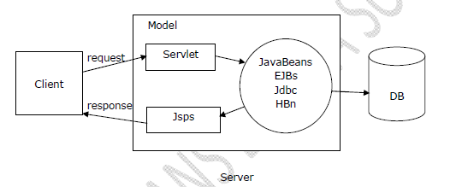

**Note 1:**

Struts is a web application framework designed on the basis of MVC architecture, where we have to use ActionServlet as controller and we have to use a set of Jsp pages as view part.

**Note 2:**

JSF (Java Server Faces) is a web application framework, where we have to use FacesServlet as a controller and a set of Jsp pages as view part.

**Enterprise:**

Enterprise is a business organization, a group of organizations running under a single label.

**Enterprise Application:**

It is a software application, which will be designed for a particular enterprise in order to simplify the internal business processing.

**To design enterprise applications we have to use the following 3 layers.**

1. User Interface Layer

2. Business Processing Layer

3. Data Storage and Access Layer

**1. User Interface Layer:**

User Interface Layer is the top most layer in enterprise application, it will provide starting point for the customers to interact with enterprise application.

**The main purpose of User Interface Layer in enterprise applications is**

1. To improve look and feel for the enterprise applications.

2. To accept user details in order to execute server side application.

3. To provide very good environment for client side validations with JavaScript functions.

4. To specify different types of requests at client browser like get, post, head and soon.

To prepare User Interface Layer in enterprise application we will use a separate logic is called as **Presentation Logic.**

To prepare presentation logic in enterprise applications we have to use technologies like AWT, SWING, HTML, JSP, Velocity and so on.

2. **Business Processing Layer:**

Business Processing Layer is the heart of the enterprise application, it will provide very good environment to define and execute all the business rules and regulations which are required by the client.

To prepare Business Processing Layer in enterprise application we will use a separate logic is called as **Business Logic.**

In enterprise application development, to prepare Business logic we have to use technologies like Servlets, Jsp's, JavaBeans, EJB’s and so on.

**3. Data Storage and Access Layer:**

This layer is the bottom most layer in enterprise applications.

The main purpose of this layer is to provide data persistency in enterprise application.

Data Storage and Access Layer will provide very good environment to provide the basic database operations (CRUD) as per the enterprise application requirement.

To prepare Data Storage and Access Layer we will use a separate logic called as **Persistence Logic.**

In enterprise application development, to prepare persistence logic we have to use technologies like Jdbc, EJB-Entity Beans Hibernate, JPA and so on.

**To design enterprise application we need to define the degree of enterprise application, for this we have to use system architectures.**

1-Tier Architecture

2-Tier Architecture  
…  
n-Tier Architecture

**1-Tier Architecture:**

To design enterprise application if we use 1-tier architecture then we have to provide **User Interface Layer, Business Processing Layer and Data Storage and Access Layer** within a single machine.

1-Tier architecture is highly recommended for standalone applications.

In 1-Tier architecture, a single machine we have to use to accommodate the complete application so that a single machine resources may not be sufficient to execute applications, it may reduce the performance of enterprise application.

1-Tier architecture will not provide any environment to handle multiple number requests; it is able to provide less sharability.

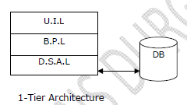

**2-Tier Architecture:**

To design any enterprise application it is minimum to use 2-Tier architecture. The best example for 2-Tier architecture is Client-Server architecture.

2-Tier architecture will allow to design and execute the application in 2 layers of machines.

In case of 2-Tier architecture, tier-1 will manage User Interface Layer and tier-2 will manage Business Processing Layer and Data Storage and Access Layers.

2-Tier architecture will provide loosely coupled design when compared with 1-Tier architecture.

2-Tier architecture will provide very good environment to handle multiple number of requests and it is able to improve sharability.

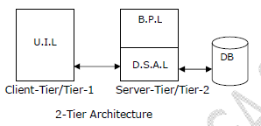

**Note:**  
As part of the enterprise application development always it is suggestible to use Tiered architectures because it will improve sharability, able to provide more loosely coupled design and so on, but we should not increase number of tiers in enterprise applications without having the requirement otherwise maintenance problems will be increased.

**Note:**

The logics and the data of standalone applications are specific to that computer where these applications are running.

The logics and data of client-server applications, two-tier applications like JDBC applications are specific to one network where they are running. In the above said two tier, client-server applications the server allows only known clients(recognized clients).

**Note:**

To provide global visibility and accessibility to the logics and data of the application use the internet environment based websites or web applications. These applications allow both the known and unknown clients having 24X7 access to the resources and logic data.

**Web Application:**

The application which is developed by only web related technologies (Servlets, Jsp, JavaScript, HTML, CSS…) is called **Web Application.**

**Example:** gmail.com, google.com

DB

Z ADVance Java

Name: __________  
Gender: ___________

Name

Submit

________________________________________________________________________________

**Process Servlet**

**Result.jsp**

**Details.jsp**

Jsp is meant for “**presentation logic”.** Hence jsp acts as **View Component**

**Servlet** is meant for “**Processing Logic”.**

Java application can communicate with database by using “**JDBC”.**

**Web Server:**

Once we develop web application, we have to place that web application in a special machine, which is nothing but web server. Hence, web server provides environment to run our web application.

Web server is responsible to provide service of our web application of our web services to the end user.

**Example:** Tomcat

**Note:**

Standalone applications, desktop applications, and client-server applications will be executed by the programmer manually. But the web resources programs of web application must be executed dynamically when they are requested by the clients (browser window), so, we can’t think about the manual execution for the web resource programs. We can use special software called **web server** to execute the web resource program dynamically when they are requested by the clients.

Web server software can also manage; execute multiple web applications simultaneously or in parallel.

**Responsibilities of web server :**

1. Listens to the client request continuously (HTTP Request).
2. It takes all client generated http requests.

2. It passes the http request to appropriate web resources of web application.

3. Web server proceeds built middle ware software.

4. Container built in controller software. Container software executes the server side programs (web resource programs).

5. Collects the output generated by the web resource programs.

6. Passes the output of web resource programs to browse window as http response in the form of web pages.

7. Provide the environment to deploy and undeploy the web application.

8. Gives middleware services etc..

**Note:**

Web Server software used to manage and execute web application and browser software used to request the web application.

**Note:**

Programmer is not responsible to develop containers and web servers but he is responsible to use them to execute web applications.

**Deployment / Undeployment:**

The process of placing web application in web server is called “**Deployment”,** so that it is ready to provide services.

The process of removing web application from web server is called “**Undeployment”.**

Deployment

Undeployment

Web App

Web Server

**Web Client:**

It is also known as “**User Agent**”.

To send the requests to the web server, we require special software, which is nothing but web client i.e. by using web client, we can communicate web server.

The most commonly used web client is browser which is **GUI** based.

**Example:** Mozilla, chrome, IE…

There are CUI based web clients also, to send the request to the web server.

**Example:** CURL, LYNX…

Request

Web Application

Response

Web Server

Web Client

**Note:**

When the web site is under development or testing in the software company, it is called as Web application. Once web application is hosted to the internet network by hosting the domain name ([www.citibank.com](http://www.citibank.com)) in the network is called as “Web Site”.

**WEB APPLICATION REQUIREMENTS :**

1. Browser software.

2. Technology to develop client side.

3. Technology to develop server side.

4. User software.

5. DataBase software.

***WEB Server Software :***

Web server software is special piece of s/w (or) special s/w which can manages the web applications and web resources we executes this web resources automatically or dynamically



The basic aim of servlet is to develop web applications.

Before servlets came into picture there was a specification called CGI.    
Servlets specification developed by SUN and released to the industry.   Lot of server vendors came forward for implementing these specifications of servlets.    
  
Servlets are nothing but set of rules given by SUN in the form of Interfaces.  The J2EE server vendors have developed their own classes by implementing the interfaces developed by SUN.

The collection of classes developed by server vendors and Interfaces developed by SUN are known as *Servlet-API*.

## Web application

A web application or website is an application program which accessed over a network connection using HTTP and often runs inside a web browser.

## Web browser

A web browser is a program which is act as an interface between user and web application e.g. Internet Explorer, Chrome, Safari, Mozilla firefox etc.

## Note:

## A file or a program is called as resource of the application.

## Container

Container provides runtime environment for Java2ee (j2ee) applications.

A web container is a predefined application provided by a server, its takes care of Servlet and JSP.

In console based java applications, a class which contains main method acts as a container for other classes.

**Note:**Container is like an **aquarium**, who can take care of whole life cycle of given resources called as **FISHES**.

1. A servlet container takes care of Servlet Program lifecycle.
2. A JSP container takes care of JSP Program lifecycle.
3. A Applet container/viewer takes care of Applet Program lifecycle.

## Operations of Container

* Life Cycle Management
* Communication Support
* Multithreaded support
* Security etc.

***Life cycle management:***

Servlet and JSP are dynamic resources of java based web application. The Servlet or JSP will run on a server and at server side. A container will take care about life and death of a Servlet or JSP. A container will instantiate, Initialize, Service and destroy of a Servlet or JSP. It means life cycle will be managed by a container.

***Communication Support***

If Servlet or JSP wants to communicate with server than its need some communication logic like socket programming. Designing communication logic is increase the burden on programmers, but container act as a mediator between a server and a Servlet or JSP and provides communication between them.

***Multithreading***

A container creates a thread for each request, maintains the thread and finally destroy it whenever its work is finished.

***Security***

A programmer is not required to write security code in a Servlet/JSP. A container will automatically provide security for a Servlet/JSP.

**Client-Server Architecture**

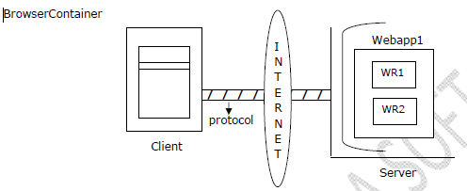

From the above representation, there are three major components in client-server architecture.

**1. Client**

**2. Protocol**

**3. Server**

**1. Client:**

The main purpose of the Client in client-server architecture is to send request to the server and to set the responses from server.

To send request and to set response from server we need to use a tool at client machine called as **Browser.** In client-server application browser is acting as client.

To access a particular resource available at server from client browser we need to specify a particular string at browser address bar called **URI.**

**There are two types of URI’s**

1. URL
2. URN

**URI** is a string specification provided at client address bar, it can be used to refer a particular resource available at server machine.

**URL** is a string specification provided at client address bar, it can be used to refer a particular resource available at server machine through its locator.

**URN** is a string specification; it can be used to refer a particular resource available at server machine through its logical name.

**Note 1:**

In case of servlets, locator is an URL pattern defined in web.xml file.

**Note 2:**

In case of servlets, logical name is a name specified along with <servlet-name> tag in web.xml file.

**Note 3:**

Almost all the servers are able to accept URL kind of request, but almost all the servers are not accept URN kind of request**.**

If we want to provide URL at client address bar then we have to use the following syntax.

**Protocol_Name://Server_IP_Address:Server_Port_No/Application_Context/Resource_Name[Query_String]**

**Ex:** http://121.120.92.98.8080/loginapp/logon?uname=abc&upwd=abc

Here Query_String, i.e. uname=abc&upwd=abc is optional.

**Q: What is the difference between IP Address and Port Number?**

**Ans:**

IP Address is a unique identification for each and every machine over Network, which will be provided by Network Manager at the time of Network Configuration.

Port Number is a unique identification to each and every process being executed at the same machine and which could be provided by the local operating system.

**Q: What is Query String and what is the purpose of Query String in web applications?**

**Ans:**

Query String is a collection of name-value pair appended to the URL, which can be used to pass input parameters to the respective server side resource in order to perform the required server side action.

2. **Protocol:**

The main job of the Protocol in client-server architecture is to carry the request data from client to server and to carry the response data from server to client.

Protocol is a set of rules and regulations, which can be used to carry the data from one machine to another machine over the Network.

**Ex:** TCP/IP, FTP, HTTP, SMTP, ARP, RARP........

In general in web applications, we will use http protocol to send request from client to server and to set response from server to client.

**Q: What is the requirement of http protocol in web applications?**

**Ans:**In web applications, to transfer the data between client and server we require a protocol, it should be

**1. A Connectionless Protocol**

**2. A Stateless Protocol**

**3. A compatible Protocol to carry hypertext data.**

Where Connectionless Protocol is protocol, it should not require a physical connection, but require a logical connection to carry the data.

Where Stateless Protocol is a protocol, which should not remember previous request data at the time of processing the later request.

In general in client server application, request data will be transferred from client to server in the form of hypertext data and the response data will be transferred from server to client in the form of hypertext data so that we require a Compatible Protocol to carry hypertext data between client and server.

Among all the protocols http protocol is able to satisfy all the above requirements so that we will use http protocol in web applications.

**Q: How http protocol is able to manage stateless nature?**

**Ans:**

In client server applications, when we send a request from client to server protocol will pick up the request and perform the following actions.

1. Protocol will establish a virtual socket connection between client and server as per the server IP address and protocol which we provided in URL.

2. Protocol will prepare the request format with header part and body part, where header part will manage all the request headers(metadata about client) and body part will manage request parameters(the data which was provided by the user at client browser).

3. After preparing request format protocol will carry request format to server through the virtual socket connection.

Upon receiving request from protocol server will identify the request resource, execute generate dynamic response and dispatch that dynamic response to client.

**When server dispatch the dynamic response to the client protocol will pick up the response and perform the following actions.**

1. Protocol will prepare response format with header part and body part, where header part will manage response headers (metadata about the dynamic response) and body part will manage the actual dynamic response.
2. After setting response format protocol will carry response format to client.
3. When the dynamic response reached to client protocol will terminate the virtual socket connection, with this protocol will eliminate the present request data from its memory.

In the above context, the present request data will be managed by the protocol up to the connections existence, will protocol connection has terminated then protocol will not manage request data.

Due to the above reason http protocol is unable to manage clients previous request data at the time of processing later request. Therefore, http protocol is a stateless protocol.

**Note:**

If we use http protocol, a stateless protocol in our web applications then we are unable to manage clients previous request data, but as per the application requirements we need to manage clients previous request data at the time of processing later request. In this context, to achieve the application requirement we have to use a set of explicit mechanism at server side called as **Session Tracking Mechanisms.**

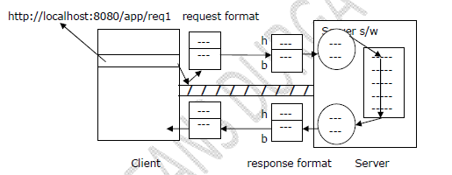

**Status Codes:**

In web applications, the main purpose of the status codes is to give the status of the request processing to the client.

Http1.1 version has provided all the status codes in the form of number representations. As per the web application requirement http1.1 version has provided the following status codes.

1xx 🡪 100 to 199 🡪 Informational status codes

2xx 🡪 200 to 299 🡪 Success related status codes

3xx 🡪 300 to 399 🡪 Redirectional status codes

4xx 🡪 400 to 499 🡪 Client side error status codes

5xx 🡪 500 to 599 🡪 Server side error status codes

In general in web applications, when we send a request from client to server, server will identify the requested resource, execute it and generate dynamic response to client.

In the above context, when server dispatches the response protocol will pick up the response and prepare response format, where the dynamic response will be stored in the response format body part.

At the time of processing response format server will provide the respective status code value in the response format header part i.e. with status line field.

When protocol carry the response format to the client then client will pick up the status code value from status line field, prepare itself to get the response from response format body part.

3. **Server:**

The main purpose of the server in client server applications is to pick up the request from client, identify the requested resource, generate the dynamic response and dispatch dynamic response to client.

**Note:**

Servlet is a program available at server machine, it is not capable to pick up the request and dispatch response to client, if server execute servlet program then some dynamic response will be generated.

**Examples of Servers:**

Apache Tomcat, BEA Weblogic, IBM Websphere, Macromedia JRun, SUN Sunone, J2EE, GlassFish and so on.

**There are 2 types of servers to execute enterprise applications.**

1. Web Servers

2. Application Servers

**Q: What are the differences between Web Servers and Application Servers?**

**Ans:**  
1.Web Server is a server, which will provide very good environment to execute web applications only. But Application servers will provide very good environment to execute any type of J2EE applications like web applications, distributed applications and so on.

2. In general web servers will not provide all the middle ware services. But application servers will provide all the middle ware services like JND, Jdbc and so on as in-built support.

|  |
| --- |
| **Application server = Web server + Middleware services** |

**Note:**

Initially the main intention of web servers is to execute static resources in order to generate static response and the main intention of application servers is to execute dynamic resources in order to generate dynamic response.

If we want to specify a particular machine has server machine then we have to install particular server software, when we install server software on server machine automatically that server software will be available in the form of the following 2 modules.

**1. Main Server**

**2. Container**

**Q: What is the difference between Main server and Container?**

**Ans:**

When we send a request from client to server then main server will pick up the request from protocol and check whether the request data is in well-formed formator not**,** if it is not in well-formed format then main server will stop request their itself and generate the respective response to client.

If the request data is in well-formed format then that request will by pass to container, where container will identify the requested resource, execute it, generate dynamic response and dispatch dynamic response to main server, where main server will bypass response to client through the protocol.

**In general containers could be classified into the following 2 ways.**

1. As per the technology which we used to design server side component. There are some containers

**1. Servlet Container** 🡪 To execute servlets

**2. Jsp Container 🡪** To execute Jsp’s

**3. EJB Container** 🡪 To execute EJB’s

**Note:** All the above specified containers can be used to execute the respective components because the above containers have implemented the respective technology API.

2. As per the containers physical existency there are 3 types of containers.

**1. Standalone Container:**

It is an integration of main server and container as a single program.

2. **Inprocess Container:**

It is a container existed inside the main server.

3. **Out of process Container:**

It is a container existed outside of the main server.

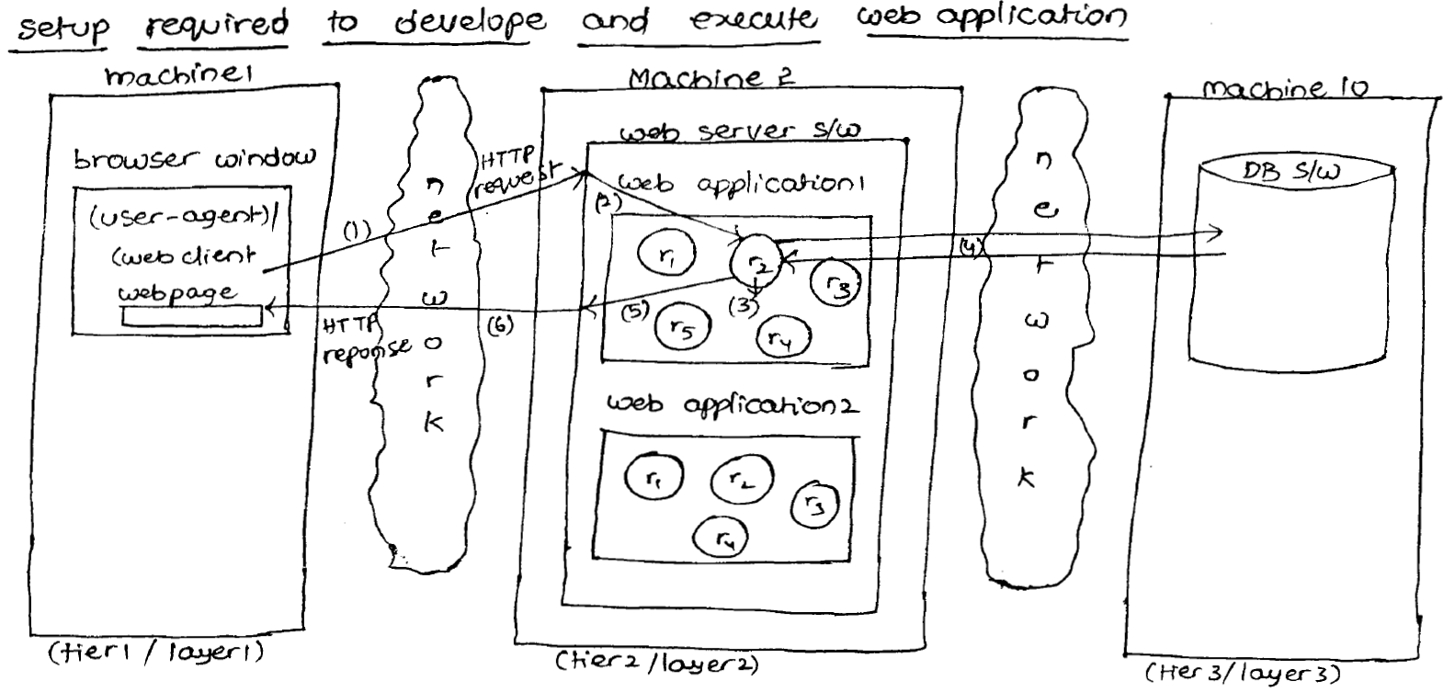

* Each window acts as one client to web application.
* A web application can be developed as two tier application without data base software or three tier applications with data base software.

**With respect to diagram:**

1. Browser window generates http request to the web application.
2. The web server traps and takes the request and passes the request to the appropriate web resource program.
3. The web resource program process the request.
4. Web resource program interacts with the data base software if necessary.
5. The web resource program generated result goes to the web server.
6. Web server sends these results to the browser window as Http response in the form of web page.

In the above diagram, r1, r2… are web resource programs.

Based on the place where web resource program executes there are two types of web resource programs.

1. Server Side web resource program (Servlet program, jsp program etc.)
2. Client side web resource program 🡪 They come to browser window from the web application placed in web server for execution.

**Example:** HTML program, JavaScript program, JSP program etc.

Decide whether the web resource program is a client side program or server side program based on the place where it executes, but not based on the place where it resides.

A web application looks like thin client-fat server application.

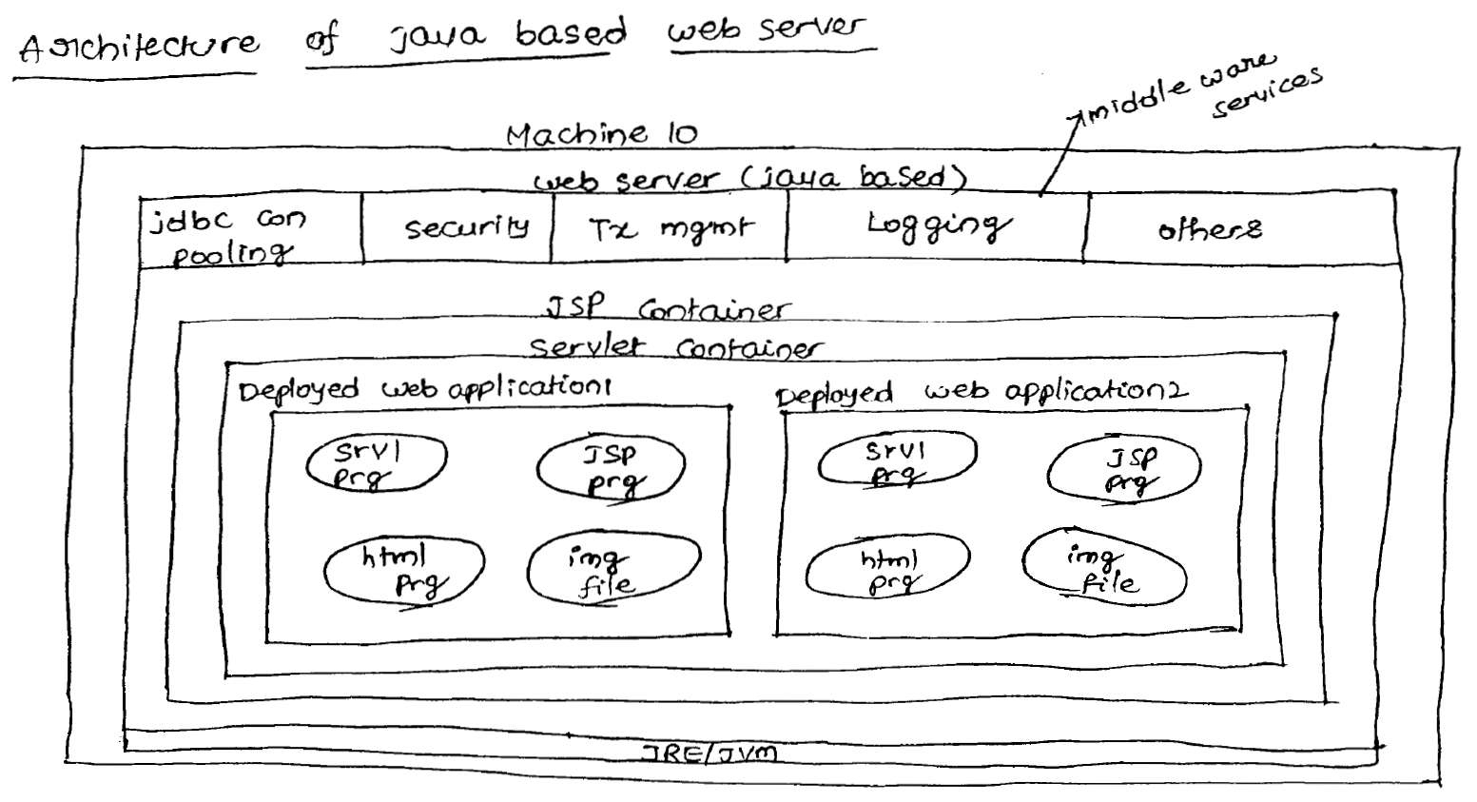

* Once web server is started one daemon process will be started to listen to client’s continuously and to trap the client generated HTTP request.
* The process that runs continuously is called as **Daemon Process.**
* **Every java application contains two default threads:**

1. Main() thread.
2. Garbage collectors thread (Daemon thread).

* JSP container is the enhancement of servlet container and both containers use JRE/JVM supplied by web server.
* Middle ware services are configurable additional services on the application to make applications executing perfectly in all the situations.
* Security middle ware service protects the application from the unauthorized and unauthenticated users.
* Transaction management services executes the logics by applying the **Do everything or nothing principle.**
* JDBC collection pool supplies set of readily available JDBC connection objects.
* Logging services keeps track of the application execution process through confirmation statements/ messages/ log messages.
* Middle ware services are not minimum logics of application development. They are additional or optional services to apply on applications.
* A web application can be there with or without middle ware services.
* Web server automatically activates the servlet container and jsp container to execute the servlet and jsp programs when they are requested by the clients.
* The client side web resource program of the web application goes to browser window for execution whereas the server side programs will be executed by using the containers of web server.
* In web application execution environment browser software is called as client software and web server software is called as server software.

**Examples of java based web servers:**

**Tomcat** 🡪 From apache foundation.

**Resin**🡪 From Resin soft.

**JWS** 🡪 From Sun Micro systems.

* HTTP is an application level protocol define in set of rules to get communication between browser window and the web server.

1. The text that allows the sequential reading is called as normal text.

**Example:** Notepad

1. The text that allows the non-sequential reading through hyperlinks is called as Hypertext.

**Example:** Any web page content.

* Protocol http is useful to transfer the hypertext between the browser window and the web server, web server and the browser window.

**Different browser softwares:**

*Internet Explorer 🡪 Micro soft.*

*Net scape Navigator 🡪 Net Scape.*

*Fire Fox🡪 Mozilla*

*Chrome🡪 Google*

*Opera 🡪 Opera soft*

**Different client side technologies (for developing the client side web resource program):**

*HTML🡪 W3C*

*JavaScript🡪 Net scape*

*VB Script 🡪 Microsoft*

*AJAX 🡪 Adaptive path*

**Note:**

The code that cannot be executed independently and it must be executed by embedding it with other technology based program for program execution is called as a **SCRIPT code.**

**Example:**

Java script code cannot be executed independently. It can be executed by embedding it with HTML code. So, Java script is called as **Scripting language.**

**Different Server side Technologies (to develop server side web resource programs):**

* **Servlet** 🡪 from Sun Micro Systems 🡪 Java based (2)
* **JSP** 🡪from Sun Micro systems 🡪 Java based (3)
* **asp**🡪from Microsoft 🡪 Non-Java Based
* **asp.net** 🡪 from Micro soft 🡪 Non-Java based (4)
* **PHP 🡪** from Apache 🡪Non-Java based (5)
* **COLD FUSION 🡪**from Adobe 🡪Non-java Based
* **SSJS 🡪**from Net scape 🡪 Non-java based

(Server Side Java Script)

**Different Web Server Softwares:**

* **Tomcat🡪**from Apache 🡪 Java based (1)
* **Resin 🡪** from Resin sift 🡪 Java based(2)
* **JSW** 🡪 from Sun Micro systems 🡪 Java based
* **Jetty 🡪** from Adobe 🡪 Java Based
* **IIS🡪** from Microsoft 🡪 non-java based (3)
* **PWS🡪** from Microsoft🡪 non-java based
* **AWS🡪** from Apache 🡪 non-java based

(Apache Web Server)

|  |
| --- |
| Application Server= web Server + EJB Container + More middle ware services |

**Note:**

EJB container is required to execute EJB components.

* A reusable java class object is called as **component.**
* Application server software is enhancement of web server software.
* Every application server software can act as web server.

**Different application server software:**

* **Weblogic**🡪from BEA systems (oracle corporation) (1)
* **Web sphere** 🡪 from IBM (3)
* **JBoss** 🡪from Apache/Red hat (4)
* **Glass Fish**🡪 from Sun Micro systems (2)
* **OlogAS**🡪 from Oracle Corporation

(Oracle log Application Server)

* **Jrun** 🡪 from macro media (adobe)

All application server softwares are java based softwares.

**Different Data Base Softwares:**

* **Oracle 🡪** Oracle Corporation(1)
* **MYSQL**🡪from Devx(3)
* **SQL SERVER** 🡪 from Micro soft (2)
* **DB2** 🡪from IBM
* **Postgresql**🡪 from University of California

**Static Response Vs Dynamic Response:**

If the response is not raised from person and time to time, such type of response is called **Static Response.**

**Example:** Login page of ICICI bank, Login page of Gmail

If the response is varied from person to person and time to time. Such type of response is called **Dynamic Response.**

**Example:** Inbox page of Gmail, balance information of ICICI bank account

**Web programming for static information:**

Web Client

Static Files

Request

Response/404

Web Server

Client sends a request for static files. Server fetches whether requested resource is available or not. If the requested response is available then the server will refresh that file as response.

If the requested resource is used available, then we will get **404** status code responses, saying “**REQUESTED RESONSE IS NOT AVAILABLE**”.

**Note:** To serve static files at server side no processing is required. Hence, web server always loves to serve the static files.

**Web programming for dynamic information:**

Response

Request

Web Server

Web Client

Static Files

Helper Application

WEB CONTAINER

**Helper Applications:**

SERVLET [Thread Based ]

JSP [Thread Based ]

PHP [Thread Based ]

ASP [Thread Based ]

CGI [ Process based ]

COLD FUSION [Thread Based ]

SERVER SIDE JAVA SCRIPT [Thread Based ]

Browser sends the request to the server.

Server will check whether the request is for static or for dynamic information based on URL.

**Example**

**Static - http://www.examplestaticsite.com/forums/the-challenges-of-dynamic-urls.html**

If the request is for static information, web server will search for the required static file. If it is available then the web server will provide that as response.

If it is not available the web server will provide **404** response, saying requested resource is not available.

If the request is for dynamic information then the web server will forward that request to some “**Helper Application”**. Helper application will analyze and process the requests and generates required dynamic response.

Helper application will forward the response to web server and web server in turn forwards the response to client.

Hence to generate dynamic response at server side, some **Helper application** must be required.

The following are various helper applications available in the market.

* SERVLET
* JSP
* PHP
* ASP
* CGI
* COLD FUSION
* SERVER SIDE JAVA SCRIPT

**Note:**

Servlet is a server side web component managed by web container to generate dynamic responses.

## Advantages of Servlet

* Better performance:
* Portability
* Robust
* Secure

**Better performance:**

Because it creates a thread for each request not process (like CGI).

**Portability:**

Because it uses java language and java is robust language.

**Robust:**

Servlet are managed by JVM so no need to worry about memory leak, garbage collection etc.

**Secure:**

Because it uses java language and java is a secure language.

## Servlet as technology

As a technology servlet provides a model of communication between a web user request and the application or program on the web server.

## Servlet as component

As a component servlet is a program which is executed in web server and responsible for dynamic content generation.

## Main tasks of servlet

* 1. Read the implicit and explicit data sent by web browser.
  2. Generate result by processing the data.
  3. Send the implicit and explicit data as a response to the web browser.

## Differences between CGI and Servlet

|  |  |
| --- | --- |
| **CGI** | **Servlet** |
| 1. CGI is process based. For every request a new process will be started. 2. Concurrency problems can’t occur in CGI because it is process based. 3. Platform dependent. 4. Can be written in variety of languages like c, c++, perl. 5. Response time is high. | 1. Servlet is thread based. For every request a new thread will be started. 2. Concurrency problems can occur in servlet because it is thread based. 3. Platform independent. 4. Can be written only in java. 5. Response time is low. |

To develop the web based applications we required “HTTP” protocol. (Server and client those are same Protocol using with http)

***Responsibilities of Servlet Container:***

1. To provide the environment to manage web resource of Web Application.

2. It Perform total life cycle operations.

3. In case of JSP to generate corresponding Generated Servlet.

**Note:**

1. J2SDK software is instalable. (through cmd prompt ).
2. J2EE is not a instalable software , It is a specification,(not through cmd prompt )
3. Specification is a document , it contain set of RULES(interfaces) and GUIDELINES(classes).
4. SERVLET ia not a technology , It is a specification.
5. Specification related package consists of more number of INTERFACES and less number of CLASSES.
6. RULES --->interfaces(method declarations)
7. GUIDELINES----> classes(concrete methods )
8. In servlets we use the instance variables are not Thread Safe.

**Web Containers:**

Web container is the best assistant to the programmer . It maintains entire life cycle of the servlet.

So that programmer has to concentrate only on Business logic.The remaining operations Instantiation of Servlet , Executing life cycle, Destroying the Servlet object and etc, taken care by Web container.

***TYPES OF WEB CONTAINER:***

**There are 3 types of web containers are possible.**

**1. Stand alone :**

Both web server and web container are available in a single integrated component, such type of web container are called Stand-alone web container.

**Ex : Tomcat**

This type of web containers is best-suitable for small scale applications and rarely used.

Web Server

Web Container

**2. In-Process Web container:**

If the web container runs in same address space (same machine) of web server and it is available as plug-in such type of web containers are called In-Process web container.

In this case both web server and web container need not be from the same vendor.

Web Server

Web Container

Same Machine

The main advantage of web container is both web server and web container need not be from the same vendor.

**Example:** We can use Apache web server and IBM web container**.**

**Note:** Apache Web server is best and Apache web container is worst.

Apache Server

Same Machine

Weblogic

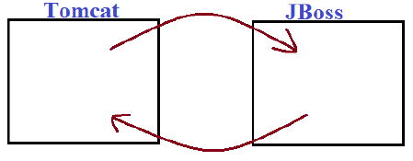

3. **Out-Process Web container:**

Web server and web container both are running on different machines, Web container is attached to the web server externally. Web container is not part of web server; web container and web server are running on different machines. Such type of web containers are called Out-process web containers.

We can configure front-end apache has to forward the request to the back-end weblogic server. These type of web containers are industry using.

Machine 1/  
Frontend Machine

Web Server

Machine 2/  
Backend Machine

Web Container

This type of web Containers are most commonly used web containers.

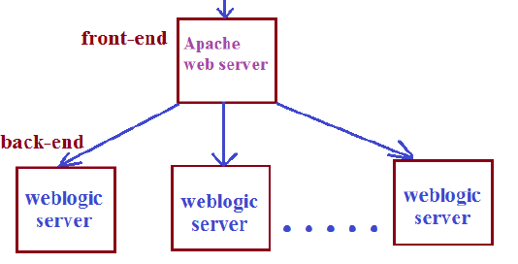

**Example:**We can configure frontend Apache Web Server to forward request to backend weblogic container.

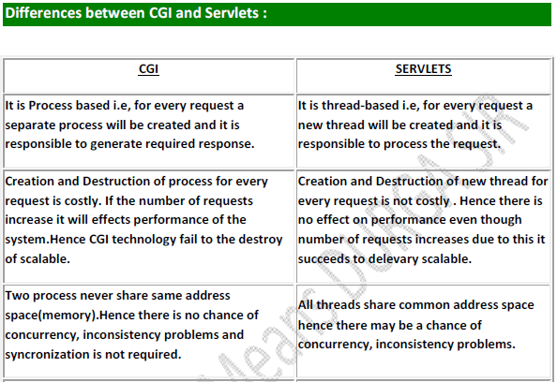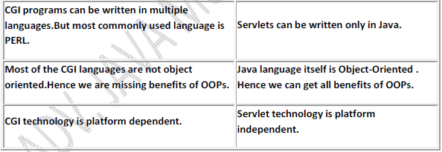

***FAST CGI :***

It improves performance when compared with traditional CGI. In this case web container maintains a pool of process so that a single process can serve multiple requests one by one.

**TOMCAT:**

**Type:** java based web server

**Version :**

Tomcat 6.0 (compatible with JDK 1.6)

Tomcat 7.0 (compatible with JDK 1.6/1.7)

Tomcat 5.0 (compatible with JDK 1.5)

**Vendor:**

Apache Foundation

**Open Source software** (the source code will be exposed).

**Default port number:** 8080 (changeable)

**To download software:** [www.apache.org](http://www.apache.org)

**For docs:** [www.apache.org](http://www.apache.org)

**For FAQ’s:** [www.forum.apache.org](http://www.forum.apache.org)

- To install Tomcat 6.0 software, use Apache 🡪 Tomcat-6.0.2.26 set up file and you can change the default port number, default username and password details during installation. If not changed default port number is “8080”, default username is “**admin”**, and default password is “**admin”.**

- Every software installed in a computer will reside in a logical position called **Software port** and every software port is identified with its own port number (communication end point).

- After installing the software, you will get default folder structure as follows.

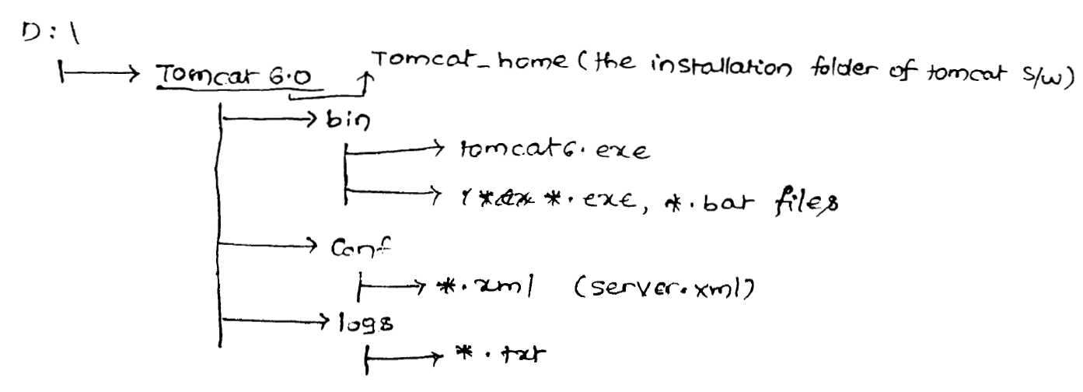

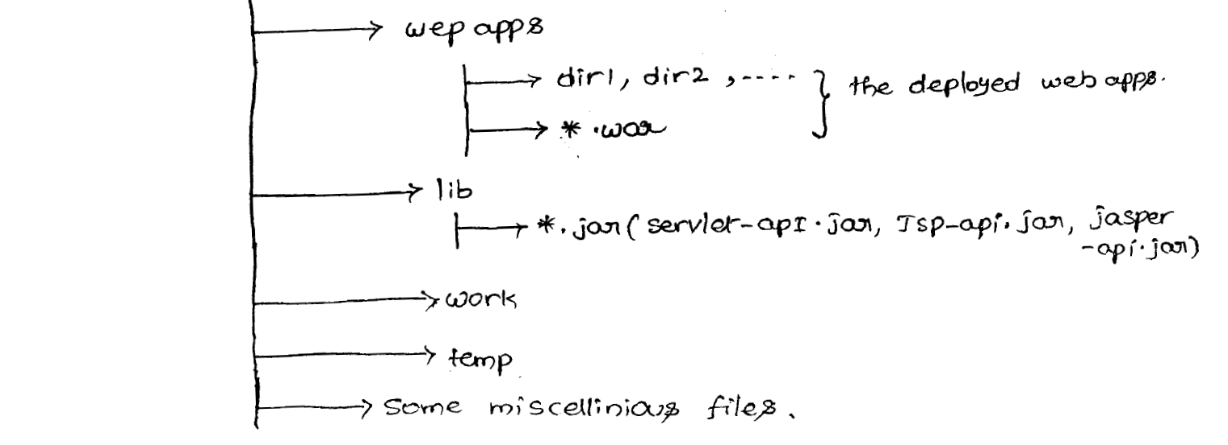

The installation folder of tomcat is called as <tomcat-home>.

To start tomcat server use <tomcat-home>/bin/tomcat6.exe file.

To launch home page of tomcat the procedure is

Open browser window 🡪 Type <http://localhost:8080/> in address bar  
here 8080 is port number of tomcat server.

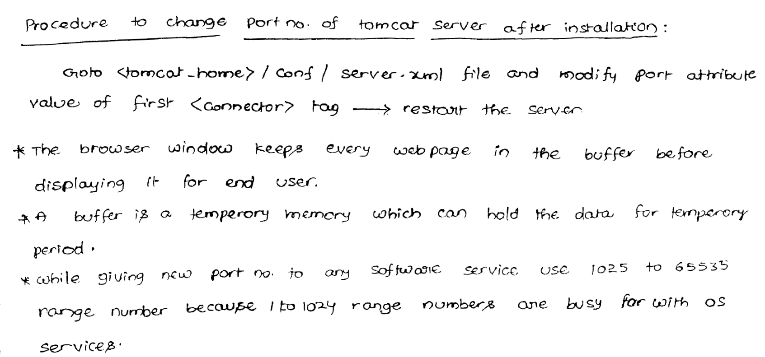

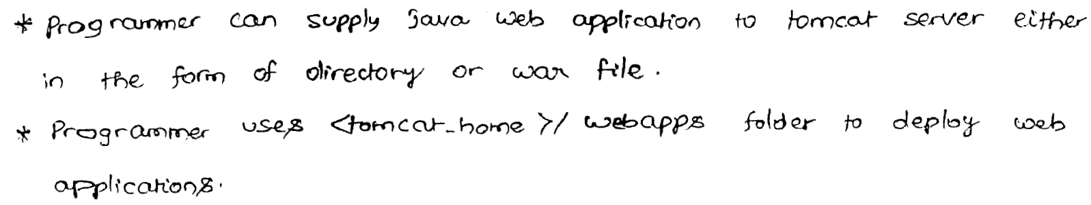

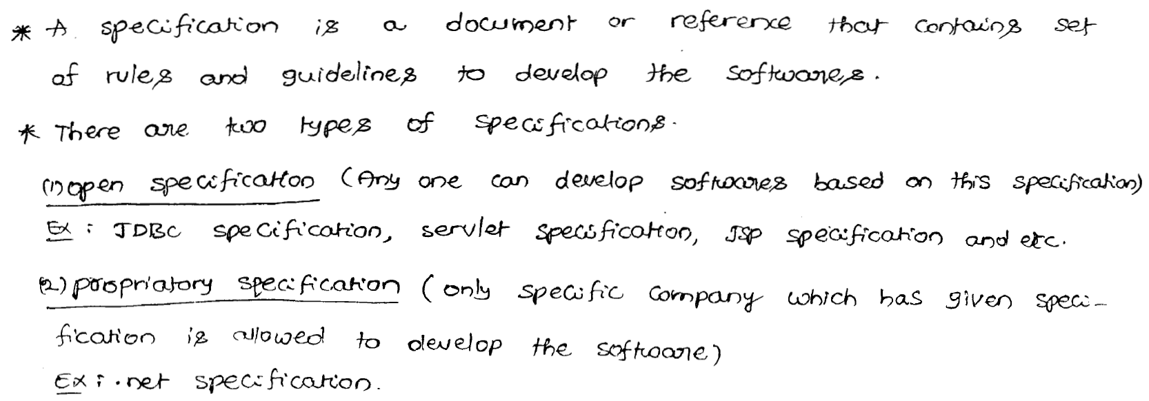

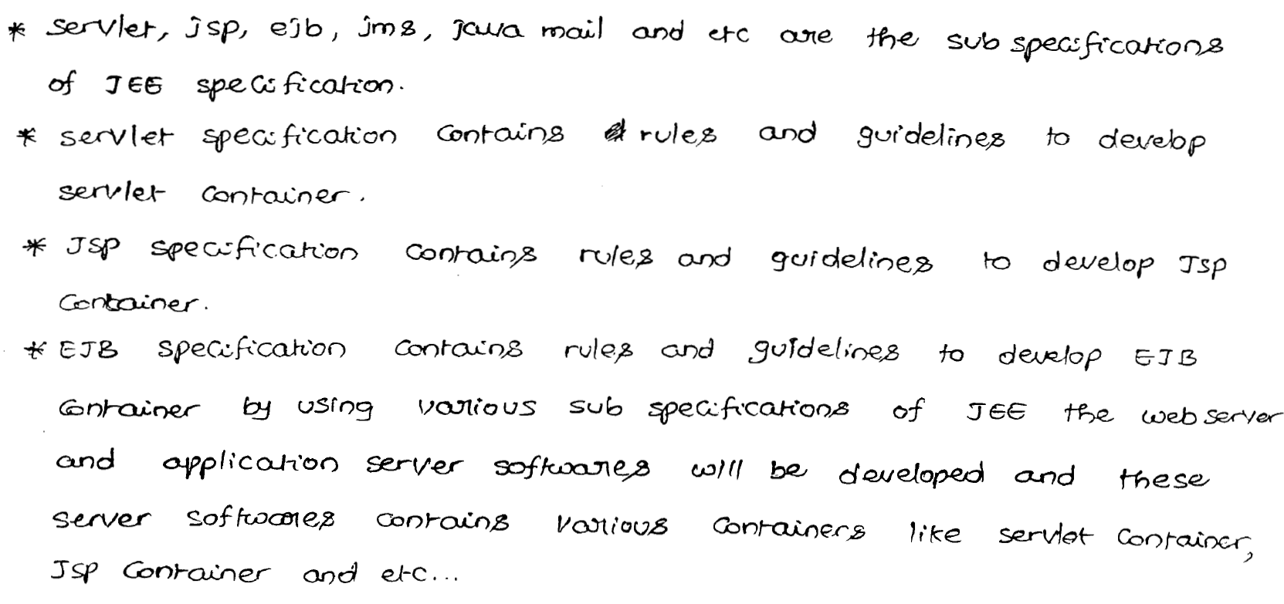

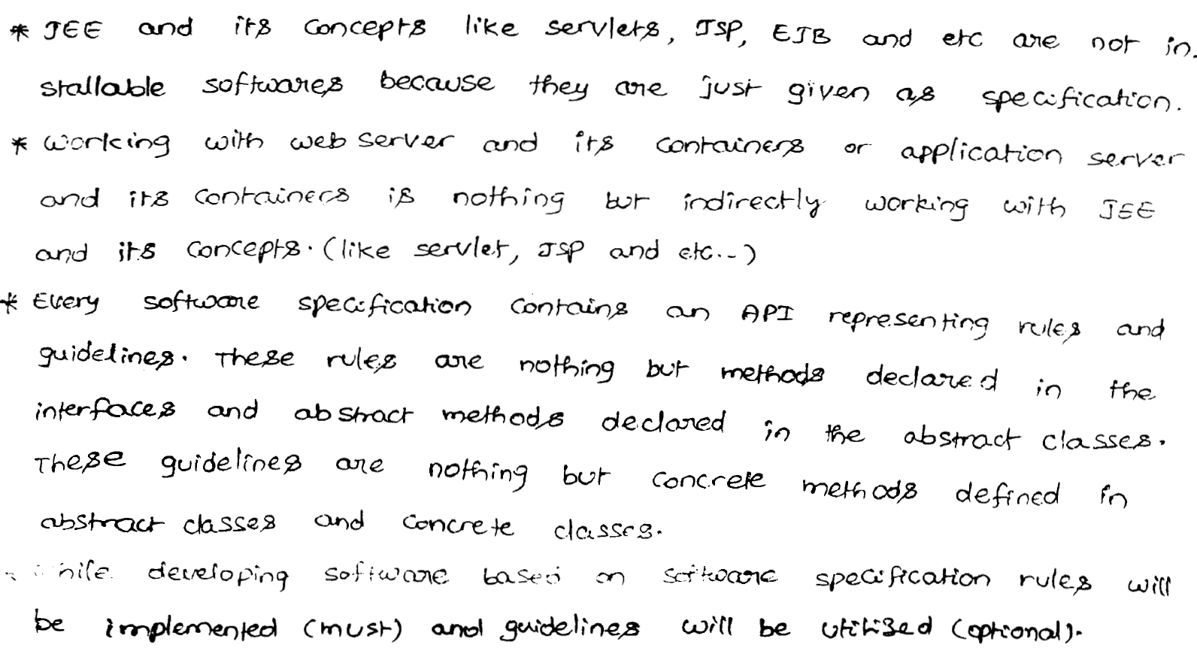

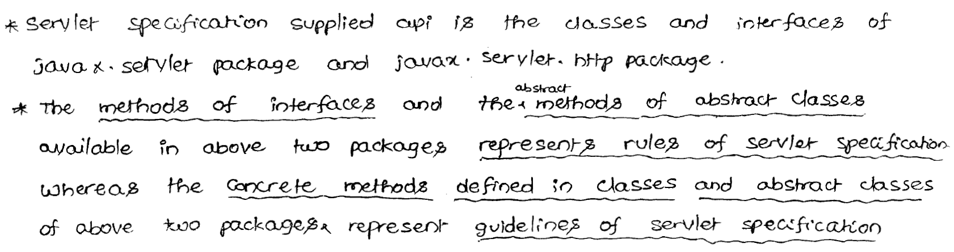

**Tomcat Components:**

WEB CONTAINER

JSP Container  
(JASPER)

Servlet Container

(Catlina)

Tomcat Web Server

Every web server internally contains web container.

Web Container is responsible to manage and execute servlets and jsp’s.

Internally web container contains containers:

1. Servlet Container
2. JSP Container

**Servlet Container:**

It is also known as Servlet Engine.

It is responsible to manage and execute servlet components.

In Tomcat, servlet container’s name is CATALINA.

**JSP Container:**

It is also known as JSP Engine.

It is responsible to manage and execute JSP components.

In Tomcat, servlet container’s name is JASPER.

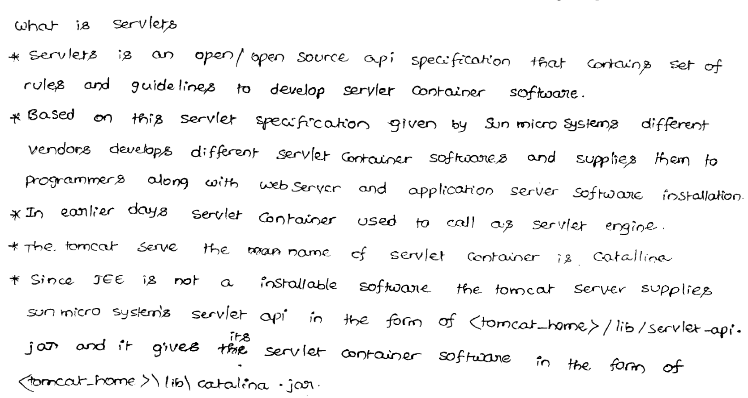

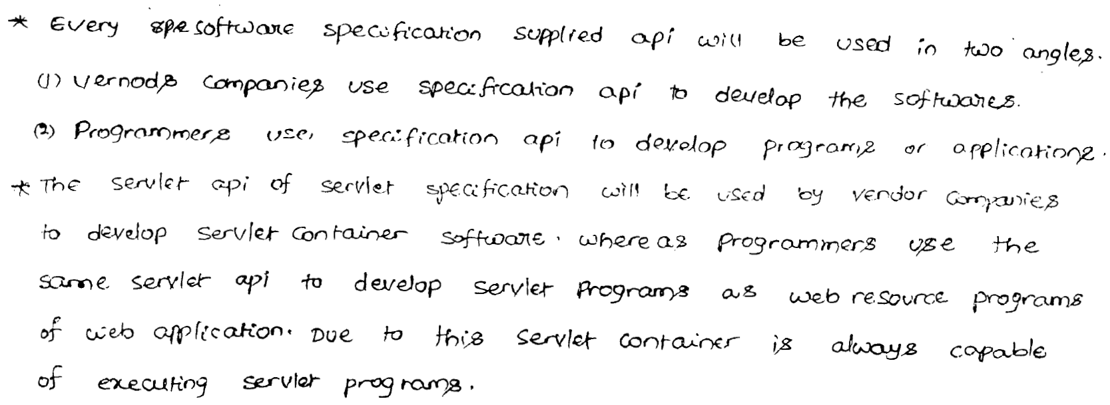

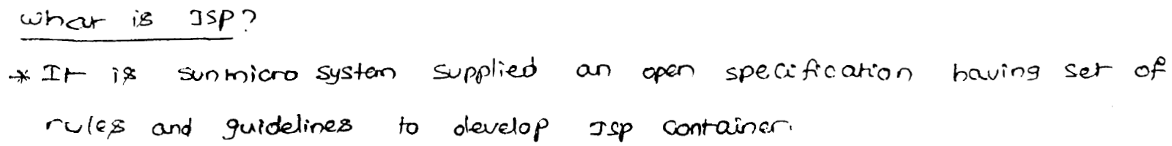

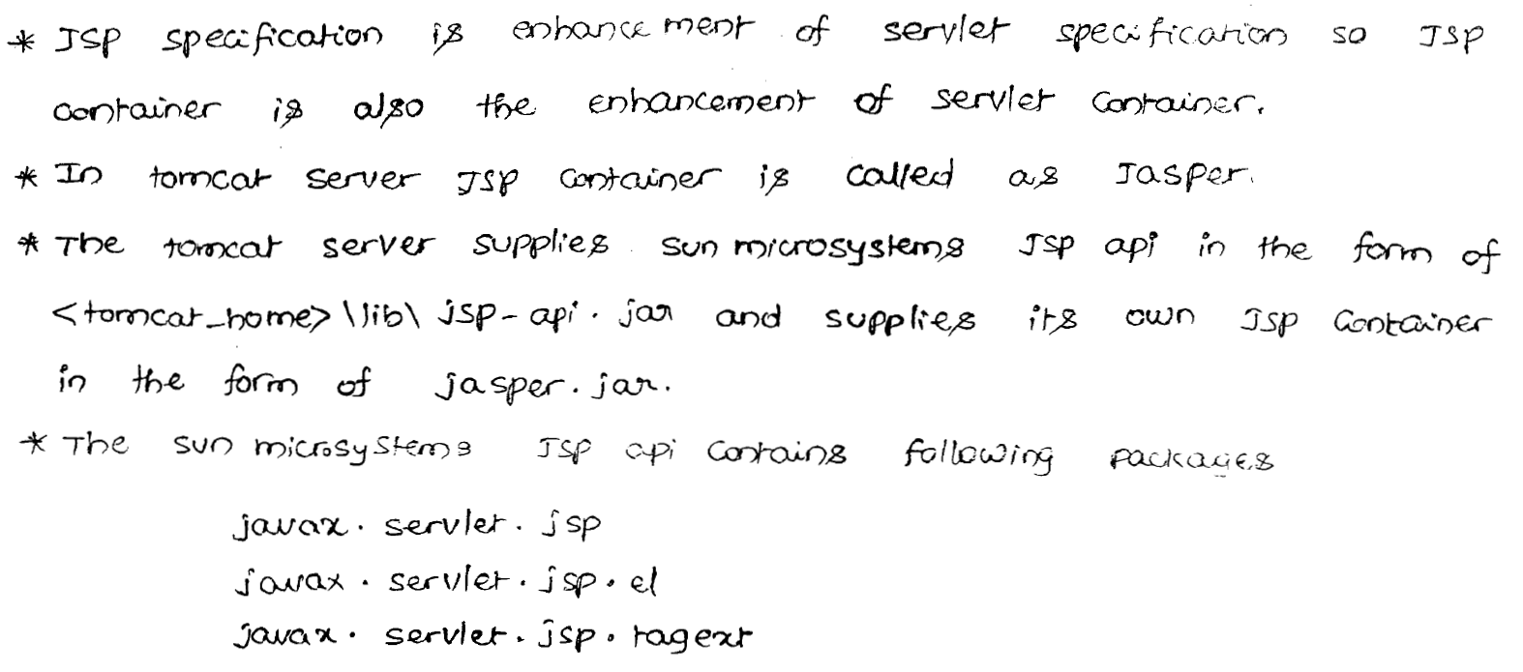

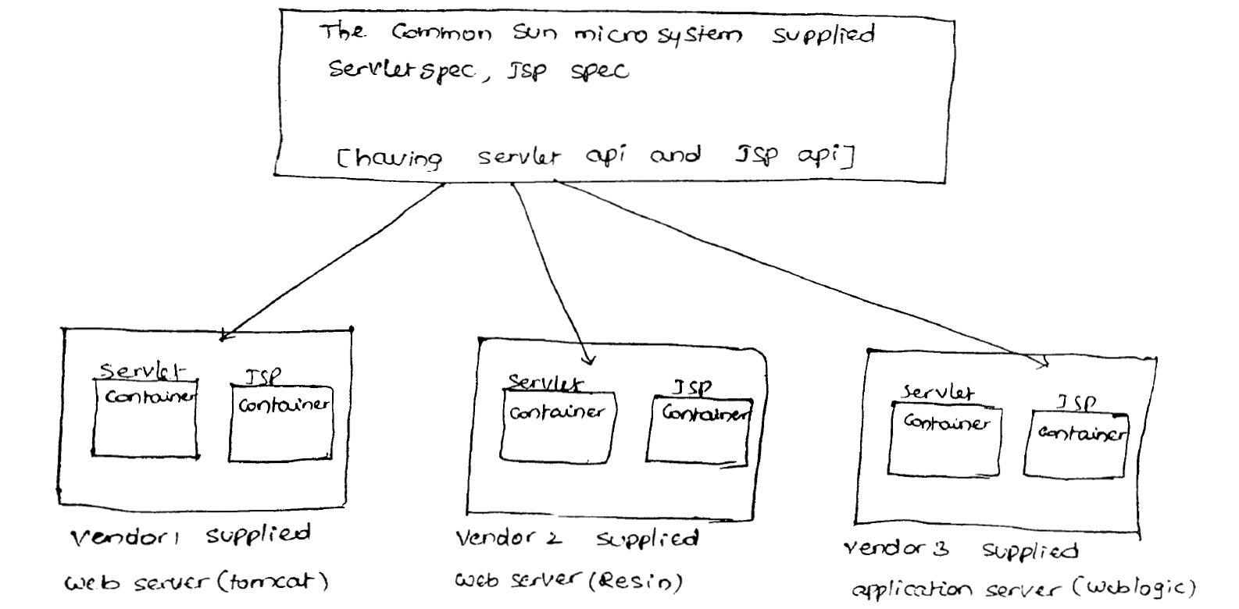 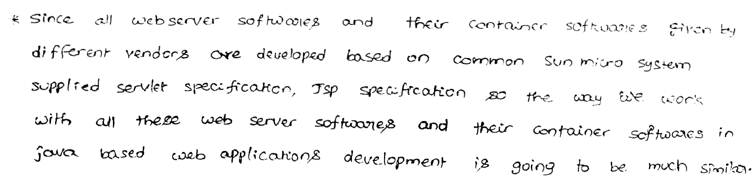 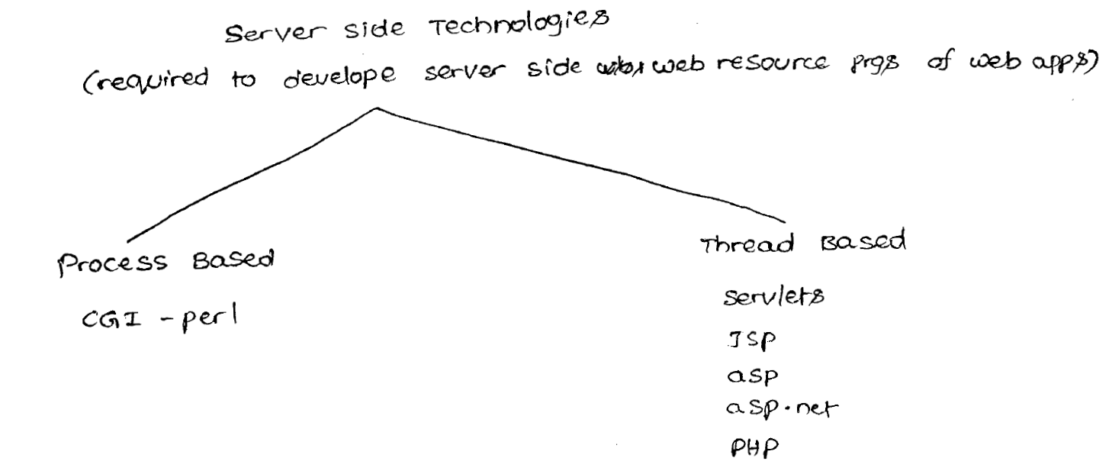

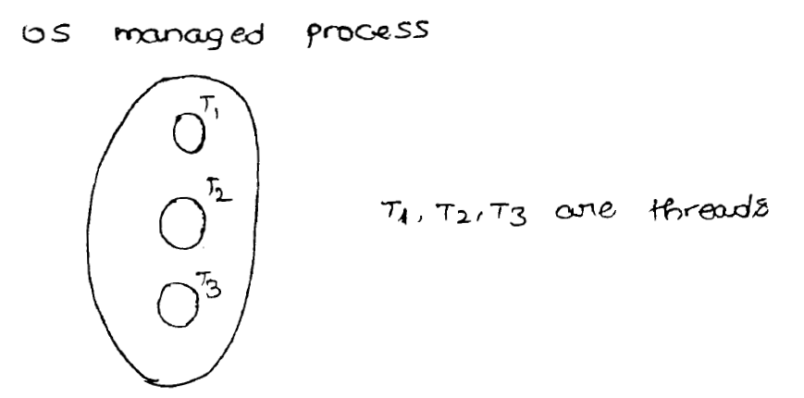

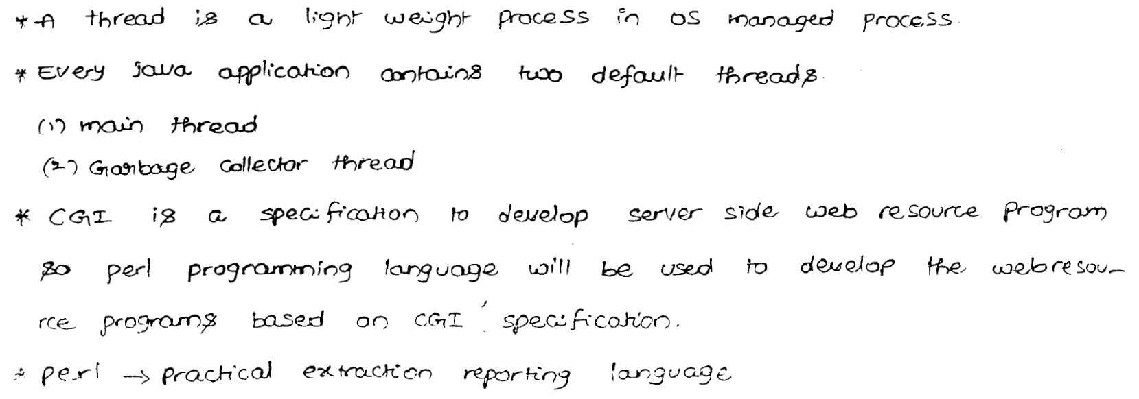

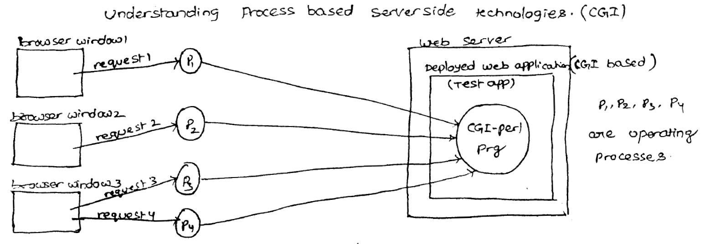

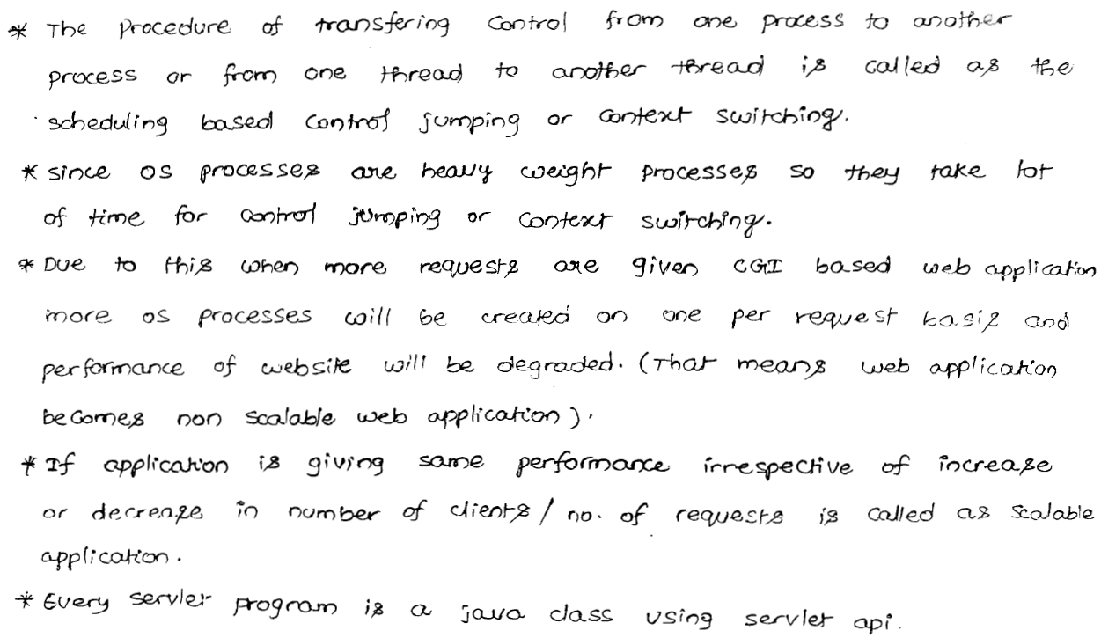

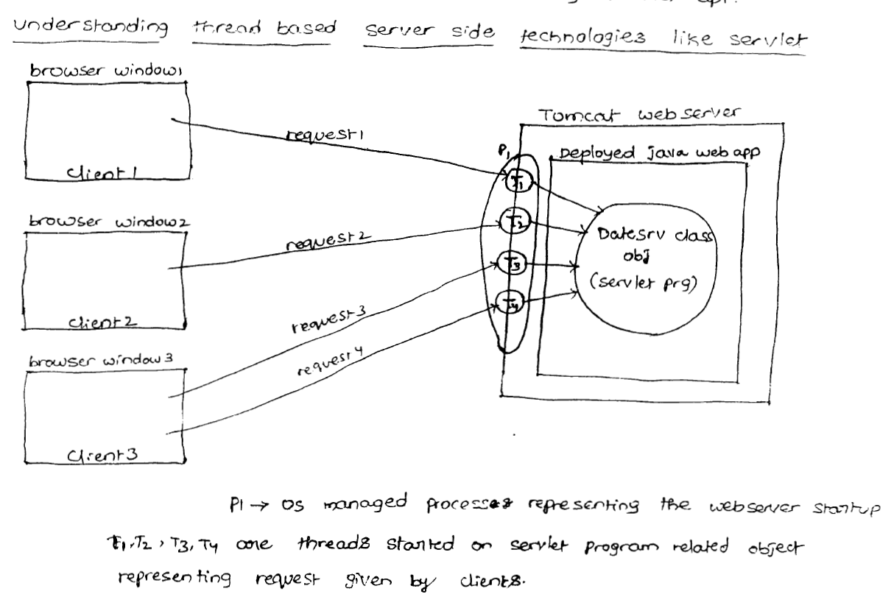



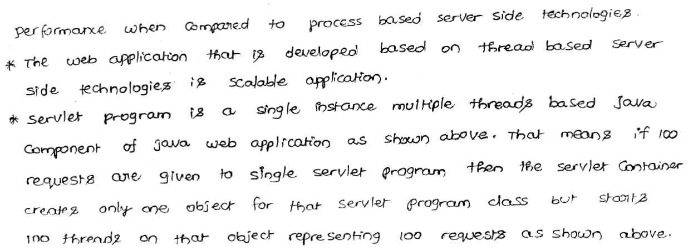

**How Servlet technology works ?**

Threads

Request 1

Request 1

Request 1

Request 1

**Example**

**Students 🡪 Chairs 🡪 Single Teacher**

For every servlet, web container creates one servlet instance (Object).

For every request, web container will allocate a separate thread, which is responsible to process that request. Hence, servlet follows “Single Instance Multi Threaded” (SIMT) model.

**Servlet defination :**

Servlet is a single instance multiple thread based server side Technology to develop Dynamic web resources of web application.

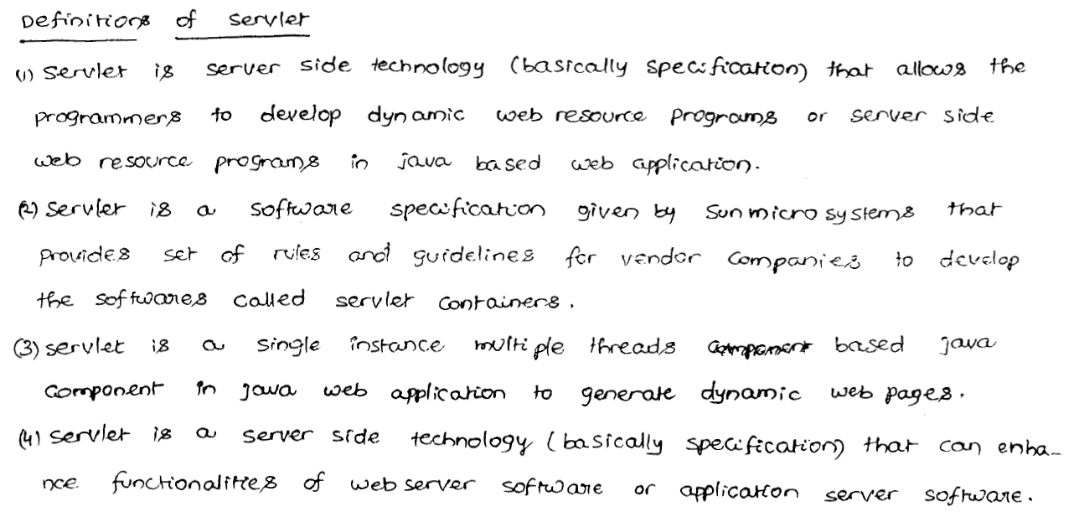 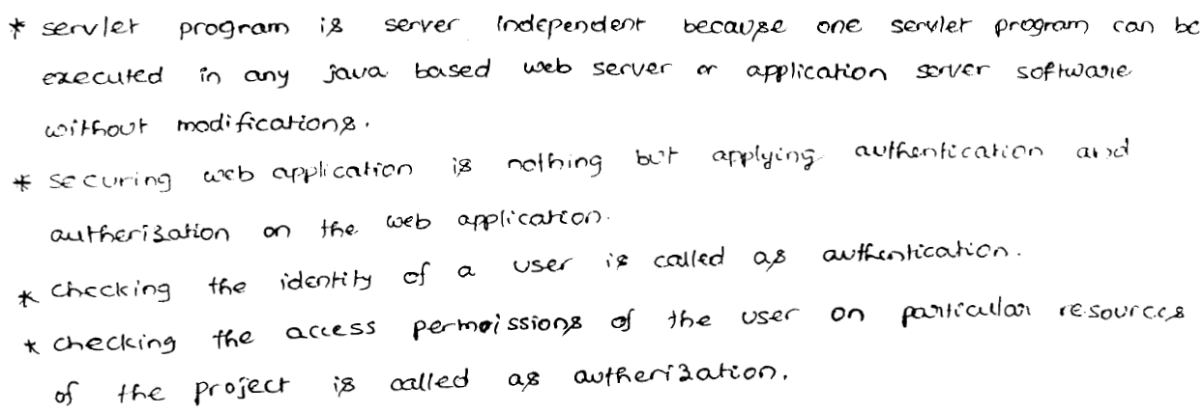

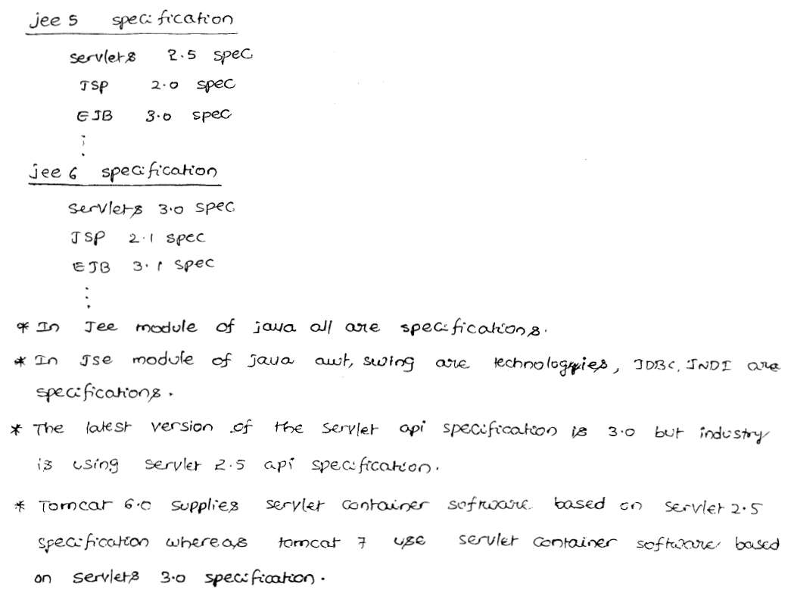

**We can develop Servlets by using the following 2 packages.**

1. **javax.servlet:**  
This package defines several classes and interfaces to develop servlets from scratch irrespective of any protocol i.e it can be used to develop protocol independent servlets (Generic Servlet).

**2. javax.servlet.http :**

This package defines several classes and interfaces, which can be used to develop http protocol based servlet.  
  
It is the sub package of javax.servlet and contains several convenient classes and interfaces to develop http based servlets.

**javax.servlet Package :**

Important interfaces of javax.servlet package:

1. **Servlet**
2. **ServetRequest**
3. **ServletResonse**
4. **ServletConfig**
5. **ServletContext**
6. **RequestDispatcher**
7. **SingeThreadedModel**

**Servlet interface:**

Every servlet in java should implement servlet interface either directly or indirectly. ie, Servlet interface acts as a root interface for all java Servlets. This interface defines the most common methods, which are applicable for any servlet object.

This interface defines the most common methods (including life cycle methods) which are applicable for any servlet object.

Public class HelloServlet implements Servlet{.

…

}

**ServletRequest Interface:**

For every request web container creates one request object. ServletRequest object can be used to hold client data.

Servlet

Web App

Server

Browser/Client

By using ServletRequest object, servlet can get clients information.

ServletRequest interface defines several methods to acts as end users provided data from the request object.

**Ex: getParameter()**

**ServletResponse Interface:**

For every request web container creates a separate response object.

ServletResponse object can be used to prepare and send responds to the client.

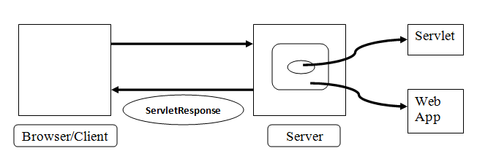

ServletResponse interface defines several methods which are required for preparation of response.

**Ex: getWriter(), setContentType()**

**\*\*\*ServletConfig Interface:**

For every servlet, web container creates one ServletConfig object to hold its configuration information like logical name of the Servlet , instantiation parameters etc.

ServletConfig interface defines several methods to access servlets configuration information.

**Ex:** getServletName(), getInitParameter()

**ServletContext Interface :**

For every web application, web container will create one separate ServletContext object to hold application level configuration information like name of the application and ServletContext parameter etc.

Web Application

By using ServletContext object, servlet can get application level configuration information.

**Note:**

1. For every request, web container creates one separate request and response objects.
2. For every servlet, web container will creates one servlet config object.
3. For every web application, web container will create one servlet context object.

***Note :***

***ServletConfig is per Servlet, whereas ServletContext is per web application.***

**6) RequestDispatcher :**

By using RequestDispatcher object we can dispatch the request from one component to another component.

The component can be either servlet or jsp.

**Response  
Dispatcher**

**Example:**

**SERVLET**

**GMAIL**

This interface defines two methods.

**1. forward()**

**2. include()**

**7) SingleThreadModel :**

Servlet technology is single instance multithreaded model. i.e. multi threads can operate simultaneously on the servlet object. Hence there may be a chance of data inconsistency problems.

We can resolve these problems by using SingleThreadModel interface. If a servlet implements SingleThreadModel interface, then a single thread can access servlet object at a time i.e. Servlet can process only one request at a time. i.e.

**Example:**

*Public class FirstServlet implements SingleThreadModel {  
…  
}*

**The main objective of SingleThreadModel interface is to provide thread-safety.**

But the problem/ disadvantage with SingleThreadModel is Servlet can process only one request at a time which impacts performance of the system. Because of this problem SingleThreadModel interface is not recommended to use and it is deprecated in Servlet **2.4** version without introducing any replacement.

Instead of SingleThreadedModel, we can provide thread-safety to the Servlet by using **synchronized** keyword.

SingleThreadModel interface doesn't contain any methods. It is a **marker interface.**

Internally JVM is responsible to provide required ability.

**Note**:

In addition to above interfaces javax.servlet package defines the following interfaces also.

**Note:**

SingleThreadModel does not solve all thread safety issues. For example, session attributes and static variables can still be accessed by multiple requests on multiple threads at the same time, even when SingleThreadModel servlets are used. It is recommended that a developer take other means to resolve those issues instead of implementing this interface, such as avoiding the usage of an instance variable or synchronizing the block of the code accessing those resources.

8) **Filter**

9) **FilterConfig**

10) **FilterChain**

----- To implements Filter Concept.

11) **ServletRequestListener**

12) **ServletRequestAttributeListener**

13) **ServletContextListener**

14) **ServletContextAttributeListener**

----- To implements Listener Concept.

**Classes of javax.servlet package : (9)**

**1) GenericServlet :**

This class implement Servlet interface and provides default implementation for every method except service( ). Hence it is an abstract class.

We can use this class as a base class to develop protocol independent servlets.

**Example:**

Public class HelloServlet extends GenericServlet{

…

}

**Servlet (I)**

**implements**

**GenericServlet**

**extends**

**HelloServlet**

2) **ServletOutputStream** :

We can use this class object to send/write binary data (pdf files , image files, video/audio files etc.) as response to the client.

3) **ServletInputStream:**

We can use ServletInputStream objects to read binary data send by the client/end user.

4) **ServletException:**

While processing our request, if servlet faces any problem then Servlet Exception will occur.

**Note**:

In addition to above classes’ javax.servlet package defines the following classes also

4) **ServletRequestWrapper**

5) **ServletResponseWrapper**

To implement wrapper concept.

6) **ServletRequestEvent**

7) **ServletRequestAttributeEvent**

8) **ServletContextEvent**

9) **ServletContextAttributeEvent**

To define Events for Listeners.

All Events are classes and Listeners are interfaces.

**Exceptions of javax.servlet package :**

**javax.servlet package defines the following 2 exceptions.**

**1. ServletException.**

Servlet can throw this exception whenever it faces any difficulty while processing client request.

**2. UnavailableException :**

It is the child class of ServletException and it is depricated .

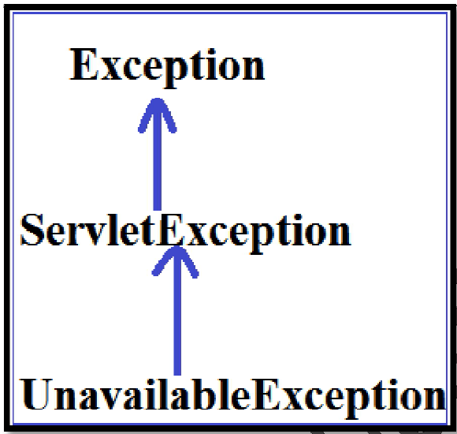

***Note*** *:*

In total javax.servlet package defines

**14 - Interfaces**

**9--Classes**

**2—Exceptions**

**javax.servlet.Servlet interface :**

Every servlet in java should compulsory implement Servlet interface either directly or indirectly i.e. Servlet interface acts as a root interface for all servlets.

This interface defines the most common methods which can be applicable for any Servlet object.

**The following are the methods defined in Servlet interface.**

1. init( )

2. service( )

3. destroy( )

4. getServletConfig( )

5. getServletInfo( )

**1. init()**

|  |
| --- |
| **public void init(ServletConfig config ) throws ServletException** |

This method will be executed only once by the web container immediately to perform initialization activities just after Servlet instantiation.

Once init() method is completed then only servlet is in position to provide service.

**Web container won't place Servlet object into service( ) method in the following cases :**

1. If init() throws ServletException.

2. If init() doesn't return with in the time period specified by web container.

In the above cases web container makes that servlet object eligible for Garbage Collection without calling any other life cycle method.

In this case web container creates a new Servlet object to provide service.

**2. service( ) :**

|  |
| --- |
| **public void service(ServletRequest request, ServletResponse response) throws ServletException, IOException** |

Web container calls this method for every request to provide response.

This method is responsible to provide required service to the end user. Entire servicing logic/business logic, we have to define in this method only.

**Note:**

For every request, web container will create separate request and response objects and by passing those objects as arguments web container will call service() method.

3. **destroy() :**

|  |
| --- |
| **public void destroy( );** |

This method will be executed only once by the web container to perform cleanup activities, whenever web container takes servlet object from out of service. This is usually happens at the time of application undeployment (or) at the time of server shut down (or) Web Container requires some free memory .

Whenever web container calls destroy( ) method , it may not be executed immediately. It will wait until completing all currently executing threads.

**Note** :

**init( ) , service( ) , destroy( ) are called life cycle methods of Servlet**.

**Note:**

We can call destroy() explicitly from the init( ) and service( ) , in this case destroy() will be executed just like a normal method call and servlet object won't be destroyed.

4. **getServletConfig** :

|  |
| --- |
| **public ServletConfig getServletConfig( );** |

This method can be used to get ServletConfig object.

By using this config object Servlet can get its configuration information.

5. **getServletInfo** ( ) :

|  |
| --- |
| **public void getServletInfo()** |

This method returns information about Servlet like Author, version, copy right information etc.

**Note:**

init(), service() and destroy are called as “**CALL BACK**” methods because these methods will be called “**AUTOMATICALLY**” by web container.

**Note**

getServletConfig() and getServletInfo() should be called ‘**explicitly’** by the programmer based on requirement and these are not call back methods.

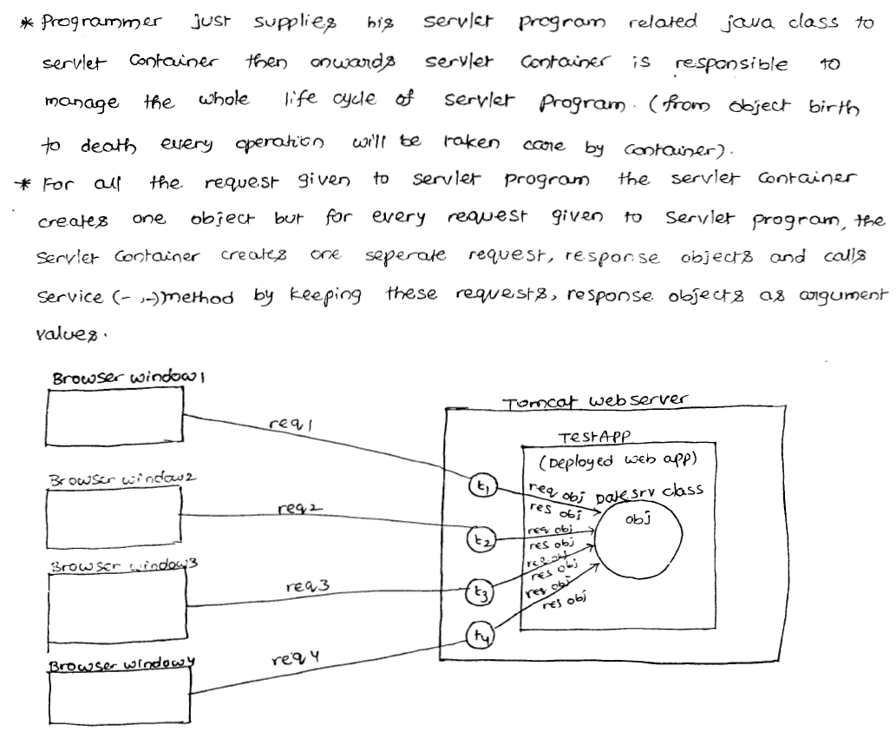

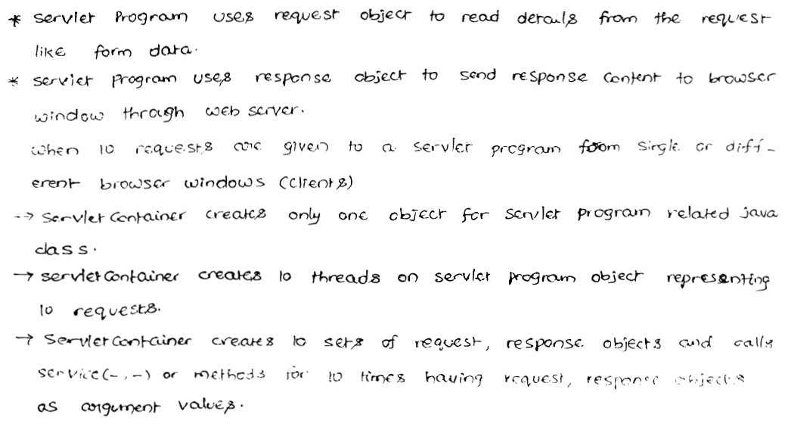

**Steps to develop first Servlet**

**Or**

**Demo program the develope a servlet by implementing Servlet interface**

**Step 1:**

**Developing Servlet by implementing servlet interface directly:**

Every servlet is a single Java class which implements servlet interface either directly or indirectly. Whenever we are implementing servlet interface, compulsory we should provide implementation for all 5 methods of Servlet interface. (i.e. init(), service(), destroy(), getServletConfig(), getServletContext()).

**Rough work:**

**Case 1:**

PrintWriter out=new PrintWritter(“abc.txt”);

Out.println(“Hello”);

out

Abc.txt

**Case 2:**

PrintWriter out=resp.getWriter();

Out.println(“Hello”);

out

resp

**FirstServlet.java:**

***import*** *java.io.*;*

***import*** *java.util.*;*

***import*** *javax.servlet.*;*

***public******class*** *FirstServlet* ***implements*** *Servlet{*

***static****{*

*System.out.println("Servlet class loading");*

*}*

***public*** *FirstServlet() {*

*System.out.println("Servlet Instantiation");*

*}*

***public******void*** *init(ServletConfig config)* ***throws*** *ServletException{*

*System.out.println("In Init method");*

*}*

***public******void*** *service(ServletRequest req, ServletResponse resp)****throws*** *ServletException, IOException {*

*System.out.println("In Service method");*

*resp.setContentType("text/html");*

*PrintWriter out=resp.getWriter();*

*out.println("<h1>This is test Servlet</h1>");*

*out.println("<h1>The Servlet time is : "+****new*** *Date()+"</h1>");*

*}*

***public******void*** *destroy() {*

*System.out.println("Indestroy method");*

*}*

***public*** *ServletConfig getServletConfig() {*

***return******null****;*

*}*

***public*** *String getServletInfo() {*

***return*** *"written by srini";*

*}*

*}*

The basic purpose of Servlet is to provide service to the end user; i.e. to provide required response to the end user.

**We can set content type of response as follows**:

|  |
| --- |
| ***resp. setContentType (“text/html”);*** |

**MIME TYPE of response**

MIME type represents the type of response we are sending to the end user. The default MIME type is “**text/html**”.

**Other MIME types are:**

* application/pdf
* image/jpg
* video/mp4

…

We can write text data (character data) to the response object by using PrintWriter**.**

We can get PrinterWriter which is pointing to the response object as follows:

|  |
| --- |
| ***PrintWriter out=resp.getWriter();*** |

By using this **PrintWriter**, if we are writing anything, it will be written to response object which will be delivered to the end user.

By using “**sopln**” statements, if we are writing any text data, it will be displayed to the server console and won’t send to end user.

**Note:**

Servlet program won’t be run by the programmer. **Web Server** is responsible to run it.

**Step 2:**

**Compilation of Servlet Class:**

After developing servlet class, we have to compile that class just like normal java class.

All dependent classes used in our servlet program are available in **servlet-api.jar**.

Web server vendor is responsible to provide this jar file.

In Tomcat installation, this jar is available in the following location:

D:\Tomcat7.0\lib

Hence to compile a servlet class, we have to place this jar file in the class path.

Then

javac FirstServlet.java

**Step 3:**

**Creation of Deployment Descriptor [web.xml]:**

For every web application, we have to provide one xml file named with web.xml.

This web.xml is also known as “**Deployment Descriptor**”.

Web container will use this xml files to get information about our servlets, i.e. web.xml acts as a guide to the web container.

**Web.xml:**

**Original Name of the Servlet**

<web-app>

<servlet>

<servlet-name>DemoServlet</servlet-name>

<servlet-class>FirstServlet</servlet-class>

</servlet>

<servlet-mapping>

<servlet-name>DemoServlet</servlet-name>

<url-pattern>/test</url-pattern>

</servlet-mapping>

</web-app>

**Logical Name of the Servlet - Object name for our servlet class, when our servlet container creates an object.**

**URL Name (or) End User Name**

**Step 4:**

**Creation of Web Applications folder structure :**

Servlet API defines some standard structure for the web application.

Suppose let’s assume the name of the web application as “**advapps1A**”.

**advapps1A**

**WEB-INF**

**Web.xml**

**Classes**

**FirstServlet.class**

Every web server can be able to understand this folder structure.

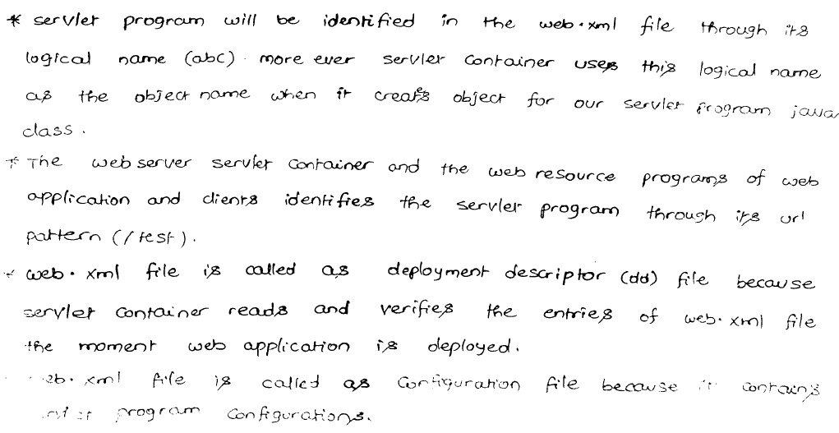  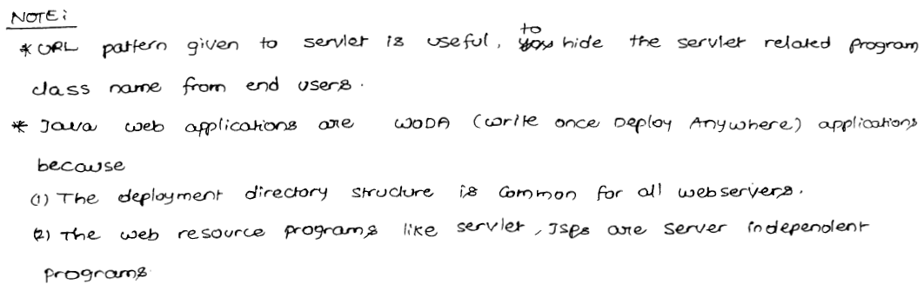

**Step 5:**

**Deployment of web application in the web server :**

Once we deployed web application according to the folder structure, we have to place this web application inside web server. This process is called “**Deployment**”. We have to place our application in the Tomcat in the following location:

**D:/Tomcat7.0/webapps**

Once we placed our application in web apps folder we can start the server and send the request as follows:

[**http://localhost:7777:advapps1A/test**](http://localhost:7777:advapps1A/test)

Here,

**http** – Protocol used by browser.

**localhost** – Machine on which web server is running.

**7777** – Port number on which web server is listening HTTP request.

**advapps1A** – Name of the application or context root.

**test** - url pattern configured in web.xml

**Note:**

To change port number in Tomcat, we have to change in server.xml and Tomcat-users.xml under config folder.

**Note:**

**advapps1A**

**Explanation**:

1. Whenever we are sending the request ,webserver checks whether this request is for static or dynamic information by using URL pattern.

2. If the request is for static information, Webserver searches for the required static file and provides required response.

3. If the request is for dynamic information, Webserver forwards that request to

Webcontainer. The webcontainer identifies the corresponding servlet class by using web.xml.

4. Webcontainer loads that .class file, perform instantiation, and execute init( ) and service( ) methods and provide required response to the webserver.

5. Webserver in-turn forwards that response to end-user.

***WithOut <load-on-startup>in web.xml :***

At the time of first request, servlet class will be loaded and servlet object will be created, followed by init() method execution. Finally service() method will be executed.

From the second request onwards, only service() method will be called.

**First Request:**

1. loading .class file (/ servlet loading)

2. Instantiation

3. init( )

4. service( )

**Second Request:**

service( )

Because of this processing time of first request is more when compared with other request.

To overcome, this problem, we should go for **<load-on-startup>** in web.xml.

***With <load-on-startup> :***

If we configure <load-on-startup>, then Servlet class loading, instantiation and execution of init() method will be performed at the time of either server startup or at the time of application deployment.

**At server startup/Application deployment**

1. loading .class file (/ servlet loading)

2. Instantiation

3. init( )

**First Request :**

service( )

**Second Request :**

service( )

Here, at the first time also, only service() method will be executed.

**Example:**

<web-app>

<servlet>

...

**<load-on-startup>10</load-on-startup>**

</servlet>

</web-app>

**Note**:

The allowed values for <load-on-startup> tag is an integer i.e., +ve , zero , -ve

**In the case of <load-on-startup> in deployment descriptor:**

* Highest value to give the least priority.
* Lowest value give high Priority
* Zero will give last priority
* -ve value means ignore the <load-on-startup> concept.

If we give the two servlets having the same <load-on-startup> value we can't expect execution order or behavior .

***What is the advantage of <load-on-startup> :***

We can equalize the response time of first request and remaining requests i.e. uniform response time.

**The main disadvantage of <load-on-startup>** **is**

It increases server start up time without any specific requirements don’t configure this <load-on-startup> on servlet.

***Note:***

From servlet 2.5v onwards a single servlet can be mapped with multiple <url-pattern>tags i.e., we can take multiple <url-pattern> tags with in single <servlet-mapping> tag.

**Ex:**

***<servlet-mapping>***

***<url-pattern>/test </url-pattern>***

***<url-pattern>/hello </url-pattern>***

***<url-pattern>/order </url-pattern>***

***</servlet-mapping>***

**Ex:**

***<servlet-mapping>***

***<url-pattern>/test </url-pattern>***

***<url-pattern>/test </url-pattern>***

***</servlet-mapping>***

**Note** :

Whenever we are writing 2 servlets having same url-pattern , if we are sending a request to particular url-pattern

The order of evaluation of web.xml is decided by the underling webserver , there is no specification rules.

* In the case of Tomcat the order of evaluation of web.xml is Bottom to Top.
* In the case of Weblogic the order of evaluation of web.xml is Top to Bottom.

**Life Cycle of the Servlet that implements Servlet interface :**

1. Client (Browser) sends a request to the server.
2. Server will check whether the request is for static or dynamic information based on url.
3. If the request is for static information, then the browser will search for the required static file. If the static file is available, then web server provides static files as response. If the required static file is not available then the server will send 404 status code, saying requested resource is not available.
4. If the request is for dynamic information, then web server forwards the request to web container.
5. Web container will identify the corresponding servlet based on url pattern and with the help of web.xml.
6. Web container will check whether servlet object is already available or not.

If it is not available, then web container will load servlet class and creates object for that servlet class and executes init() method.

Servlet class loading 🡪 By using class.forName() method.

Servlet Instantiation 🡪 by using new Instance() method.

1. Web container will call required service() method, which is responsible to provide required response.
2. Finally, web container will call destroy() method to perform cleanup activities.

This is usually performed at the time of server shut down or at the time of application undeployment.

**Note:**

* **Object O=class.forName(“FirstServlet”).newInstance();** 🡪 Here, web container will always call—public no-arg constructor.
* Servlet class loading by class loader.(It is part of Jvm).
* Servlet Instantiation by web container , For this web container always calls public-no argument constructor.

**Note**

Internally web container is responsible to create servlet object; for this web container always calls newInstance() method.

Internally newInstance() method calls, public no-arg constructor.

Hence, every servlet class should compulsory contains, public no-arg constructor. Otherwise we will get run time exception saying:

“**Java.lang.Instantiation Exception**”.

(It may be of our own or compiler generated).

**Note:**

* If we don’t keep class as public, we will get 404 error.
* Change constructor and add one argument, then 404 error again.

(Constructor will generate automatic constructor only, if we don’t have it in our class).

Q. **The main advantage of the constructor is to perform initialization of object. But in servlets, we are depending on init() method instead of constructor. What is the need ?**

**A.**

To perform initialization of servlet, compulsory config object must be required. We can’t pass config object as argument to constructor because web container always calls “**PUBLIC-NO ARG CONSTRUCTOR**”.

Hence, to perform initialization of servlet, some special mechanism must be required which is nothing but init().

Public FirstServlet() 🡺 This is a constructor. Here, It can’t take arguments.

Public init(ServletConfig config) 🡺 It can take arguments.

**Note:**

**If we want to communicate to the data base :**

Public class FirstServlet implements Servlet{

…

Public void init(…){

|  |
| --- |
| **Code to connect to DB** |

Connection con=…..;  
 String user=config.getInitParam(“user”);

|  |
| --- |
| **Retrieve details from config file** |

}

Public… service(…){

|  |
| --- |
| **Code to perform DB** |

}

Public … destroy(…){

Con.close();

|  |
| --- |
| **//Code for cleanup connections.** |

}

}

**Web Application Directory Structure – IN DEPTH:**

If we want to design any web application then we have to prepare the following directory structure at server machine.

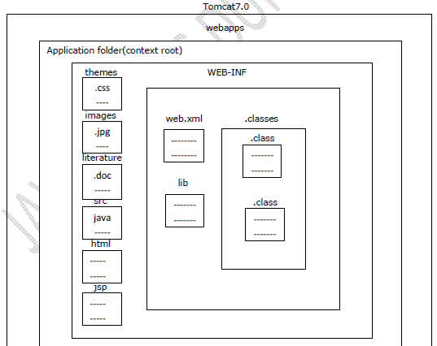

When we install Tomcat server automatically Tomcat7.0 folder will be created. In

Tomcat7.0 folder, the main purpose of webapps folder is to accommodate all the web applications provided by the developer.

To represent our own web applications in server we have to prepare a separate folder under webapps folder i.e. application folder or context root. Inside the application folder,

1. **Themes:**

To store .css files(cascade style sheet) to generate reports.

1. **Images:**

To store logos of the organizations, background sceneries and so on in the form of .jpg, .jpeg, .gif files.

1. **Literature:**

To store documentations in the form of .doc, .docex and so on.

1. **src(Source code):**

It can be used to store all the source files like Java files.

5. Along with all these folders it is possible to provide some static resources directly like .html files and dynamic resources like .jsp files.

**WEB-INF folder will include**

1. **web.xml:**

This xml file can be used to store the metadata about the web application required by the container to perform a particular action.

1. **lib:**

It is able to manage jar files which are required by the server side components.

1. **classes:**

It will include .class files of servlets, filters, listeners and so on.

**The above web application directory structure was divided into the following**

1. **Private area:**

In web application directory structure, WEB-INF folder and its internal is treated as private area. If we deploy any resource under private area then client is unable to access that resource by using its name directly.

**Note:** In general we will keep servlet .class files under classes folder i.e. private area so that we are unable to access that servlet by using its name directly from client.

To access any servlet we have to define an URL pattern in web.xml file w.r.t this servlet, with the defined URL pattern only client is able to access the respective servlets.

2. **Public area:**

The area which is in outside of WEB-INF folder and inside the application folder is treated as public area. If we deploy any resource under public area then client is able to access that resource by using its name directly.

**Note:**

In general in web applications, we are able to keep html files under application folder i.e. public area so that we are able to access that resources by using its name directly from client.

**Deployment Descriptor or web.xml file – IN DEPTH:**

Deployment Descriptor is web.xml file; it can be used to provide the metadata about the present web application required by the container in order to perform a particular server side action.

In web applications, web.xml file include the following configuration details w.r.t the web application.

**1. Welcome Files Configuration**

**2. Display Name Configuration**

**3. Servlets Configuration**

**4. Filters Configuration**

**5. Listeners Configuration**

**6. Context Parameters Configuration**

**7. Initialization Parameters Configuration**

**8. Session Time Out Configuration**

**9. Load On Startup Configuration**

**10. Error Page Configuration**

**11. Tag Library Configuration**

**12. Security Configuration**

In general in web applications, we will deploy the servlets .class files under classes folder of the web application directory structure i.e. private area.

If we deploy any resource under private area then client is unable to access that resource through its name, client is able to access that resource through alias names or locators. In case of servlets, client is able to access servlet classes through the locators called as **URL Patterns.**

If we provide multiple number of servlets under classes folder and we provide a particular request to a particular servlet available under classes folder with an URL pattern then container should require mapping details between URL patterns and servlets class names as metadata in order to identify w.r.t servlet.

In the above context, to provide the required metadata to the container we have to provide servlet configuration in web.xml file. To provide servlet configuration in web.xml file

**We have to use the following xml tags.**

*<web-app>*

*--------*

*<servlet>*

*<servlet-name>logical_name</servlet-name>*

*<servlet-class>fully qualified name of servlet</servlet-class>*

*</servlet>*

*<servlet-mapping>*

*<servlet-name>logical_name</servlet-name>*

*<url-pattern>urlpattern_name</url-pattern>*

*</servlet-mapping>*

*--------*

*</web-app>*

**Note:**

In the above servlets configuration, <servlet-name> tag value under <servlet> tag

and <servlet-mapping> tag must be same.

**Ex:**

*<web-app>*

*<servlet>*

*<servlet-name>loginservlet</servlet-name>*

*<servlet-class>com.dss.login.LoginServlet</servlet-class>*

*</servlet>*

*<servlet-mapping>*

*<servlet-name>loginservlet</servlet-name>*

*<url-pattern>/login</url-pattern>*

*</servlet-mapping>*

*</web-app>*

If we want to access the above servlet then we have to provide the following URL at client browser.

**http://localhost:8080/loginapp/login**

In servlet configuration, there are 3 ways to define URL patterns.

***1. Exact Match Method***

***2. Directory Match Method***

***3. Extension Match Method***

1. **Exact Match Method:**

In Exact Match Method, we have to define an URL pattern in web.xml file, it must be prefixed with forward slash(“/”) and pattern name may be anything.

**Ex:**

*<url-pattern>/abc/xyz</url-pattern>*

If we define any URL pattern with exact match method then to access the respective resource we have to provide an URL pattern at client address bar along with URL, it must be matched with the URL pattern which we defined in web.xml file.

**Ex:**

*http://localhost:8080/app1/abc/xyz* ***Valid***

*http://localhost:8080/app1/xyz/abc* ***Invalid***

*http://localhost:8080/app1/xyz* ***Invalid***

*http://localhost:8080/app1/abc* ***Invalid***

**Note:**

In general in web applications, we will prefer to use exact match method to define an URL pattern for a particular servlet when we have a requirement to access respective servlet independently.

2. **Directory Match Method:**

In Directory Match Method, we have to define an URL pattern in web.xml file, it must be prefixed with forward slash(“/”) and it must be terminated with “*”.

**Ex:**

*<url-pattern>/abc/*</url-pattern>*

If we define any URL pattern with this method then to access the respective resource from client we have to specify an URL pattern at client address bar it should match its prefix value with the prefix value of the URL pattern defined in web.xml file.

**Ex:**

*http://localhost:8080/app1/abc/xyz* ***Valid***

*http://localhost:8080/app1/xyz/abc* ***Invalid***

*http://localhost:8080/app1/abc* ***Valid***

*http://localhost:8080/app1/abc/abc* ***Valid***

**Note 1:**

In general in web applications, we will prefer to use directory match method to define an URL pattern when we have a requirement to pass multiple number of requests to a particular server side resource.

**Note 2:**

In web applications we will use Filters to provide preprocessing and post processing to one or more number of servlets. In this context, when we send a request to respective servlet then container will bypass all the requests to the respective Filter.

To achieve this type of requirement we have to use directory match method to define an URL pattern for the respective Filter.

3. **Extension Match Method:**

In Extension Match Method, we have to define an URL pattern in web.xml file, it must be prefixed with “*” and it must be terminated with a particular extension.

**Ex:**

*<url-pattern>*.do</url-pattern>*

If we define an URL pattern with this method then to access the respective server side resource from client we have to specify an URL pattern at client address bar, it may start with anything, but must be terminated with an extension which was specified in web.xml file.

**Ex:**

*http://localhost:8080/app1/login.do* ***Valid***

*http://localhost:8080/app1/reg.do* ***Valid***

*http://localhost:8080/app1/add.xyz* ***Invalid***

*http://localhost:8080/app1/search.doo* ***Invalid***

**Note 1:**

In general in web applications, we will prefer to use extension match method to define an URL pattern when we have a requirement to trap all the requests to a particular server side resource and to perform the respective server side action on the basis of the URL pattern name if we provided at client browser.

**Note 2:**

If we design any web application on the basis of MVC then we have to use a servlet as controller, where the controller servlet has to trap all the requests and it has to perform a particular action on the basis of URL pattern name. Here to define URL pattern for the controller servlet we have to use extension method.

In web applications, web.xml file is mandatory or optional is completely depending on the server which we used.

In Apache Tomcat Server, web.xml file is optional when we have not used servlets, filters and so on. In Weblogic Server, web.xml file is mandatory irrespective of using servlets, filters and so on.

Up to servlets2.5 version [J2EE5.0] it is mandatory to provide web.xml file if we use servlets, listeners, and filters and so on in our application. But in servlets3.0 version, there is a replacement for web.xml file i.e. Annotations, Annotations will make web.xml file is optional.

In web applications, it is not possible to change the name and location of the deployment descriptor because container will search for deployment descriptor with web.xml name under WEB-INF folder as per its predefined implementation.

**Prepare Web Resources- – IN DEPTH:**

If we want to prepare custom exceptions, threads and so on in Java applications then we have to use some predefined library provided by Java API.

Similarly if we want to prepare servlets in our web applications then we have to use some predefined library provided by Servlet API.

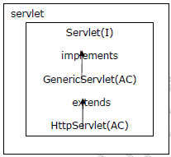

To design servlets Servlet API has provided the following predefined library as part of javax.servlet package and javax.servlet.http package.

**Q: What is Servlet? and in how many ways we are able to prepare servlets?**

**Ans:**

Servlet is an object available at server machine which must implement either directly or indirectly Servlet interface.

As per the predefined library provided by Servlet API, there are 3 ways to prepare servlets.

1. **Implementing Servlet interface:**

In this approach, if we want to prepare servlet then we have to take an user defined class which must implement Servlet interface.

***public class MyServlet implements Servlet***

***{***

***--------***

***--------***

***}***

2. **Extending GenericServlet abstract class:**

In this approach, if we want to prepare servlet then we have to take an user defined class as a subclass to GenericServlet abstract class.

***public class MyServlet implements GenericServlet***

***{***

***--------***

***--------***

***}***

3. **Extending HttpServlet abstract class:**

In this approach, if we want to prepare servlet then we have to take an user defined class as a subclass to HttpServlet abstract class.

***public class MyServlet implements HttpServlet***

***{***

***--------***

***--------***

***}***

**Start the Server – IN DEPTH:**

There are 3 ways to start the server.

1. Execute either startup.bat file or Tomcat7 Service Runner available under bin folder of Tomcat server.

***C:\Tomcat 7.0\bin***

2. Use system program monitor Tomcat

Start-All Programs-Apache-Tomcat 7.0-Monitor Tomcat

3. Use Apache Tomcat System Service Start Type services. MVC in search field Select Apache Tomcat 7.0 Select Start Service Icon.

**Access the Web Application – IN DEPTH:**

There are 2 ways to access the web applications.

1. Open web browser and type the complete URL on address bar.

**http://localhost:8080/app1/servlet**

2. Open web browser type the URL up to

<http://localhost:8080>

If we do the above automatically the Tomcat Home Page will be opened, where we have to select Manager Applications, provide username and password in Security window and click on OK button.

If we do the above automatically list of applications will be opened, where we have to select the required application.

**First Approach to Design Servlets (Implementing Servlet interface)- – IN DEPTH:**

If we want to design a servlet with this approach then we have to take an user defined class it should be an implementation class to Servlet interface.

***public interface Servlet {***

***public void init(ServletConfig config)throws ServletException;***

***public void service(ServletRequest req, ServletResponse res)throws ServletExcepption;***

***public ServletConfig getServletConfig();***

***public String getServletInfo();***

***public void destroy();***

***}***

***public class MyServlet implements Servlet***

***{ -------***

***------- }***

Where the purpose of init(_) method to provide servlets initialization.

**Note:**

In servlets execution, to perform servlets initialization container has to access init(_) method. To access init(_) method container has to create ServletConfig object.

ServletConfig is an object, it will manage all the configuration details of a particular servlet like logical name of servlet, initialization parameters and so on.

In servlet, the main purpose of service(_,_) method is to accommodate the complete logic and to process the request by executing application logic.

**Note:**

In servlet, service(_,_) method is almost all same as main(_) method in normal Java application.

When we send a request from client to server then container will access service(_,_) method automatically to process the request,

where the purpose of getServletConfig() method is to get ServletConfig object at servlet initialization.

Where getServletInfo() method is used to return generalized description about the present servlet.

Where destroy() method can be used to perform servlet reinstantiation.

To prepare application logic in service(_,_) method we have to use the following conventions.

1. **Specify response content type:**

To specify response content type to the client we have to use the following method from ServletResponse.

**public void setContentType(String MIME_TYPE)**

where MIME_TYPE may be text/html, text/xml, image/jpeg, img/jpg and so on.

**Ex:**

res.setContentType(“text/html”);

**Note:** The default content type in servlets is text/html.

When container encounters the above method then container will pick up the specified MIME_TYPE and container will set that value to content type response header in the response format.

When protocol dispatch the response format to client, before getting the response from response format body part first client will pick up content type response header value i.e. MIME_TYPE, client will prepare itself to hold the response as per the MIME_TYPE.

**2.** While executing the servlet we have to generate some dynamic response on response object, where to carry the dynamic response to the response object Servlet API has provide a predefined PrintWriter object internally.

To get the predefined PrintWriter object we have to use the following method from ServletResponse.

**public PrintWriter getWriter()**

**Ex:** PrintWriter out=res.getWriter();

**Note:**

To compile servlet we have to set classpath environment variable to servletapi.jar provided by Tomcat server at C:\Tomcat7.0\lib\servlet-api.jar.

**Ex:** set classpath=%classpath%;C:\Tomcat7.0\lib\servlet-api.jar;

To access the above application we have to use the following URL on client address bar.

<http://localhost:2020/firstservletapp/ms>

**Servlets Flow of Execution:**

When we start the server the main job of container is to recognize each and every web application and to prepare ServletContext object to each and every web application.

While recognizing web application container will recognize web.xml file under WEB-INF folder then perform loading, parsing and reading the content of web.xml file.

While reading the content of web.xml file, if container identifies any context data in web.xml file then container will store context data in ServletContext object at the time of creation.

After the server startup when we send a request from client to server protocol will pick up the request then perform the following actions.

1. Protocol will establish virtual socket connection between client and server as part of the server IP address and port number which we specified in the URL.

2. Protocol will prepare a request format having request header part and body part, where header part will maintain request headers and body part will maintain request parameters provided by the user.

3. After getting the request format protocol will carry request format to the main server.

Upon receiving the request from protocol main server will check whether the request data is in well-formed format or not, if it is in well-formed then the main server will bypass request to container.

Upon receiving the request from main server container will pick up application name and resource name from request and check whether the resource is for any html page or Jsp page or an URL pattern for a servlet.

If the resource name is any html page or Jsp page then container will pick up them application folder and send them as a response to client.

If the resource name is an URL pattern for a particular servlet available under classes folder then container will go to web.xml file identifies the respective servlet class name on the basis of the URL pattern.

After identifying the servlet class name from web,xml file container will recognize the respective servlet .class file under classes folder then perform the following actions.

**Step 1**:

**Servlet Loading**:

Here container will load the respective servlet class byte code to the memory.

**Step 2:**

**Servlet Instantiation**:

Here container will create a object for the loaded servlet.

**Step 3:**

**Servlet Initialization:**

Here container will create ServletConfig object and access init(_) method by passing ServletConfig object reference.

**Step 4:**

**Creating request and response objects(Request Processing):**

After the servlet initialization container will create a thread to access service(_,_) method, for this container has to create request and response objects.

**Step 5:**

**Generating Dynamic response:**

By passing request and response objects references as parameters to the service(_,_) method then container will access service(_,_) method, executes application logic and generate the required response on response object.

**Step 6:**

**Dispatching Dynamic response to Client:**

When container generated thread reaching to the ending point of service(_,_) method then container will keep the thread in dead state, with this container will dispatch the dynamic response to main server from response object, where main server will bypass the response to the protocol.

When protocol receives the response from main server then protocol will prepare response format with header part and body part, where header part will manage all the response headers and body part will manage the actual dynamic response.

After getting response format protocol will carry that response format to the client.

**Step 7:**

**Destroying request and response objects:**

When the response is reached to the client protocol will terminate the virtual socket connection between client and server, with this container destroy the request and response objects.

**Step 8:**

**Servlet Deinstantiation:**

When container destroy request and response objects then container will go to the waiting state depends on the container implementation, if container identifies no further request for the same resource then container will destroy servlet object.

**Note:**

In servlet execution, container will destroy ServletConfig object just before destroying the servlet object.

**Step 9:**

**Servlet Unloading:**

After servlet deinstantiation container will eliminate the loaded servlet byte code from operational memory.

**Step 10:**

**Destroying ServletContextobject:**

In the above servlet life cycle, all the objects like request, response and ServletConfig are destroyed before servlet deinstantiation, but still Servlet object is available in memory.

In general ServletContext object will be destroyed at the time of server shut down.

**Drawbacks of First Approach:**

To design servlets if we use this approach we have to provide implementation for each and every method declared in Servlet interface irrespective of the actual application requirement.

The above approach will increase burden to the developers and it will increase unnecessary methods in web applications.

To overcome the above problem we have to use an alternative i.e. GenericServlet.

***Note:***

If we are invoking destroy( ) explicitly inside service( ) that time any exception will be raised the exception will show to the end-user, when we won't handle this situation.

If web-container calls destroy( ) then that time the exception will be raised the exception that surpressed by the web-container.

**Constructor Vs init( ) :**

* In general , we can use constructor to perform initialization activities but in old versions of java, constructor cannot accept dynamically generated class name as argument.
* To perform initialization of servlet compulsary we should provide ServletConfig object as argument. whose class name is dynamically generated by web-container
* As constructor cannot accept these dynamically generated names, Sun people ignores constructor concept and introduced a specific method init( ) to perform initialization activities , which can take dynamically generated class names as the arguments.
* In the older versions , constructor cannot take any arguments but to perform initialization of a servlet compulsary we should provide ServletConfig as argument.
* Hence we can't use constructor to perform initialization activities , Sun people introduced a specific methods init( ) . for this , which can take ServletConfig as argument.

**destroy( ) Vs finalise( ) :**

Before destroying any object Garbage collector always calls finalise( ) to perform cleanup activities. But we can't expect exact behaviour of Garbage collector which is vendor dependent.

Hence instead of depending on finalise( ) , Sun people introduced a specific method destroy( ) to perform cleanup activities , which should be executed always.

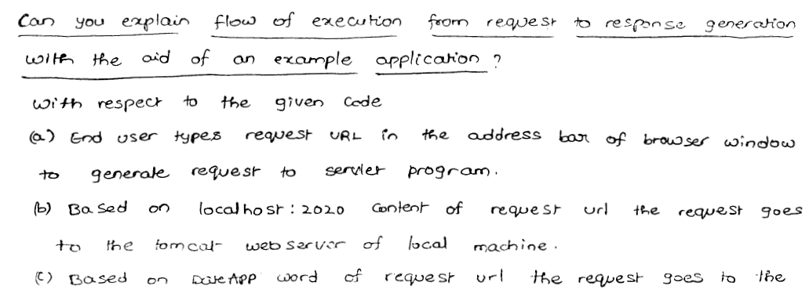



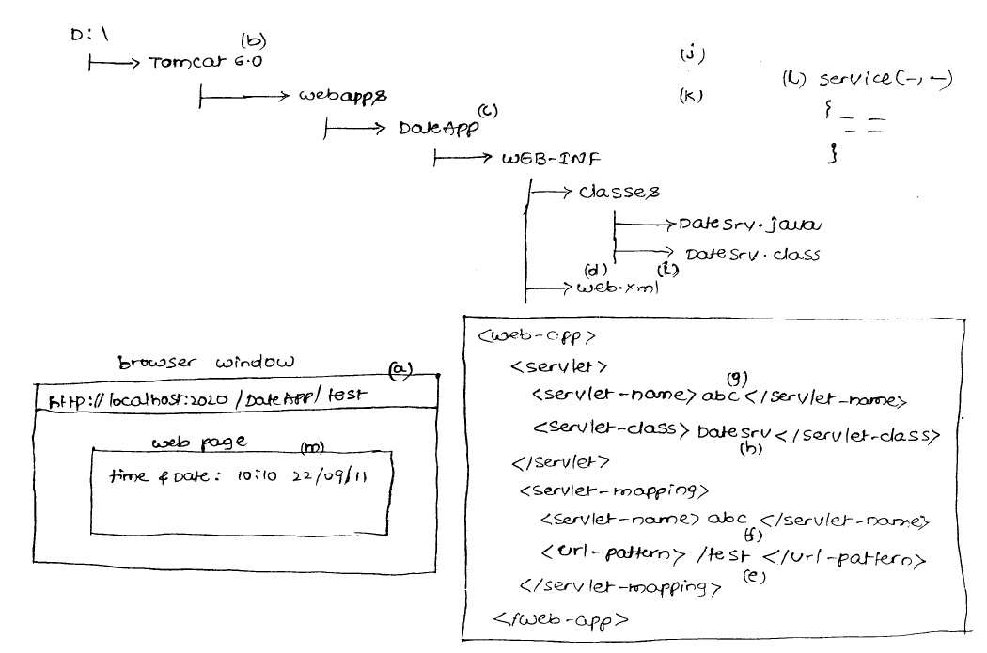

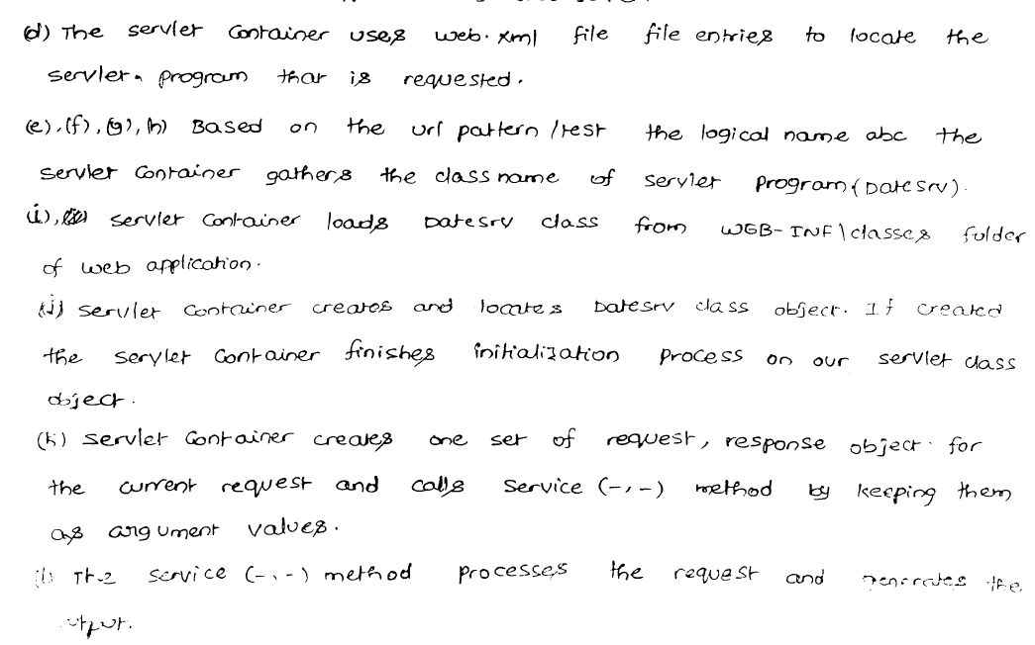

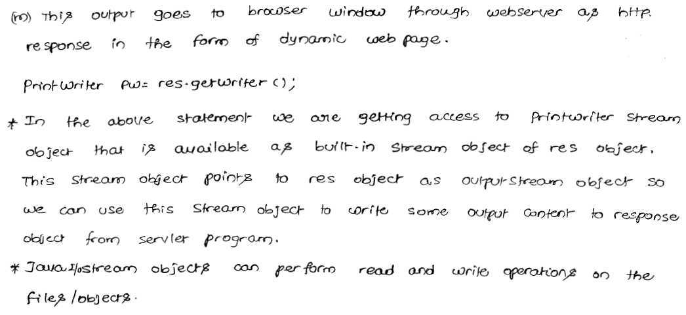

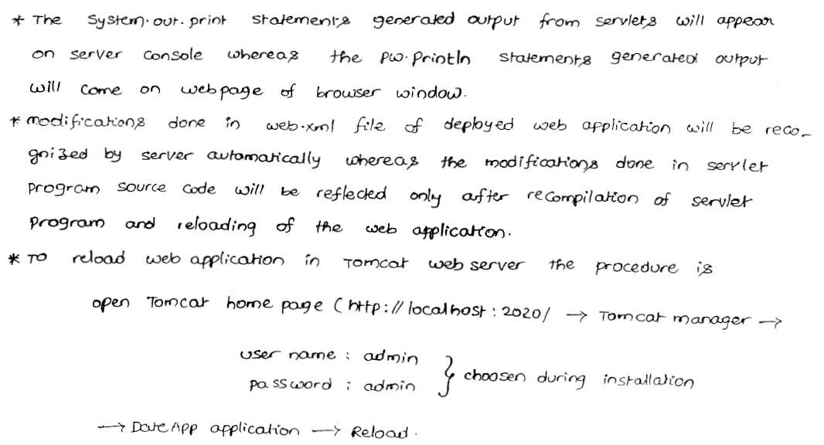

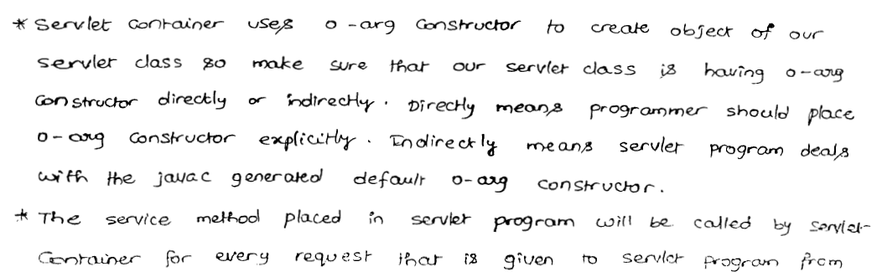

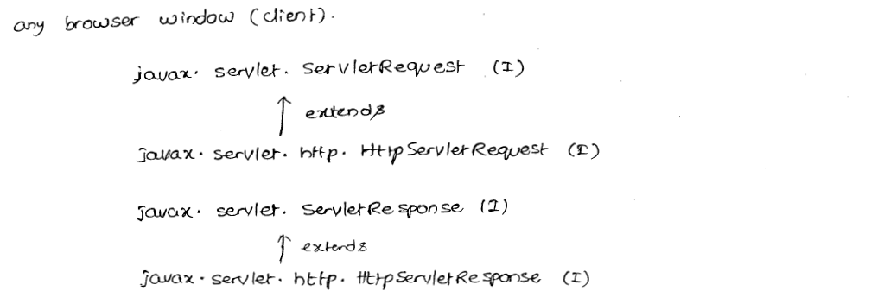

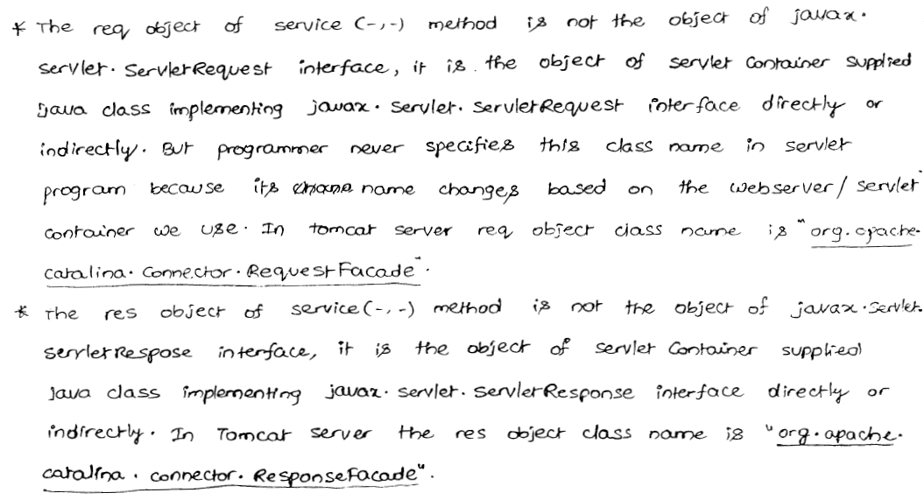

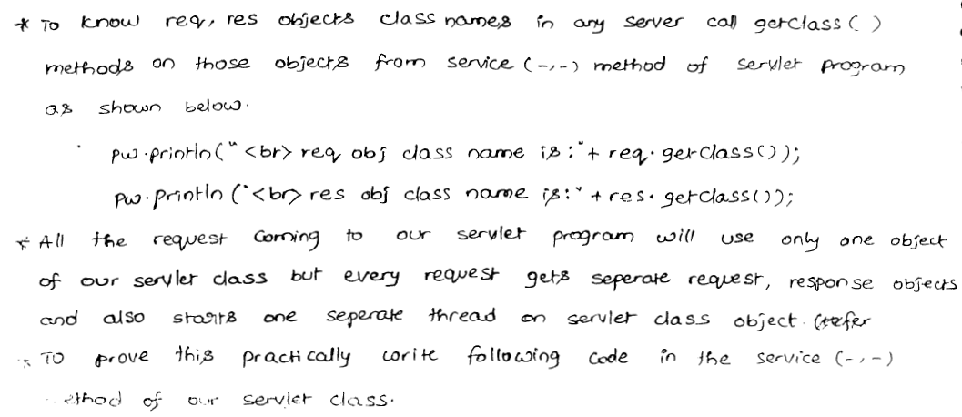

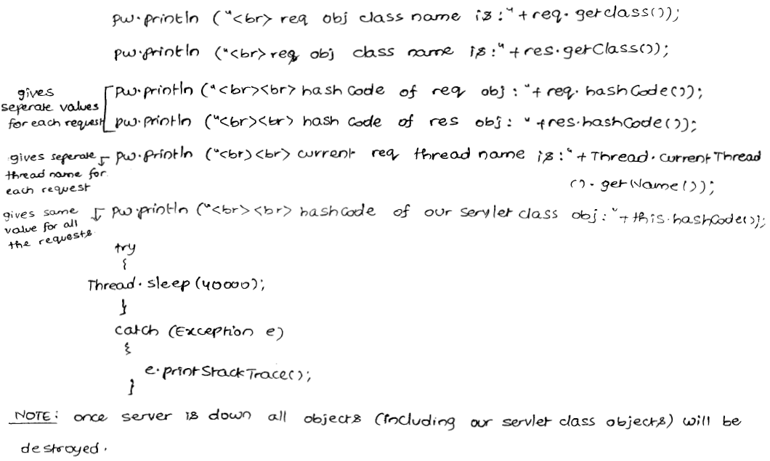 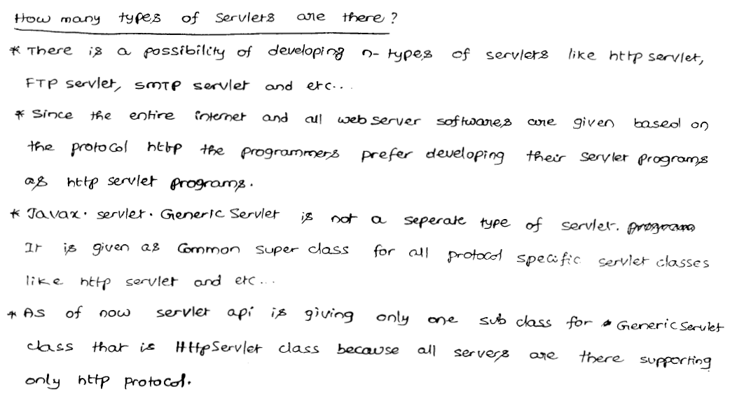

**GenericServlet(AC):**

* We can develop servlet by implementing Servlet interface directly. In this approach compulsory we should provide implementing for all methods of servlet interface whether it is required or not. This approach increase length of the code and reduces readability. We can resolve this problem by using GenericServlet.
* GenericServlet implements Servlet interface and provide default implementation for every method except service ( ). Hence it is an abstract class.
* We can develop servlets very easily by extending GenericServlet, instead of implementing Servlet interface directly. In this approach we have to provide implementation only for required methods instead of implementing all. It reduces length of the code and improves readability.
* GenericServlet is protocol independent servlet.
* GenericServlet implements ServletConfig and Serializable interfaces also.

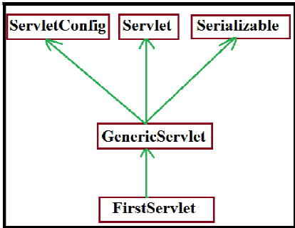

**Demo program to develope Servlet by extending GenericServlet :**

*public class FirstServlet extends GenericServlet {*

*public void service(ServletRequest request,ServletResponse response)*

*throws ServletException, IOException {*

*PrintWriter pw=response.getWriter();*

*pw.println("Developing Servlet by GenericServlet");*

*System.out.println("This is Service() in First Servlet ");*

*}*

*}*

**Internal implementation of GenericServlet :**

*public abstract class GenericServlet implements Servlet, ServletConfig, Serializable {*

*private transient ServletConfig config ;*

*public void init(ServletConfig config) throws ServletException {*

***this.config=config ; //webcontainer purpose***

***init( );***

*}*

*public void init( ) throws ServletException {*

***//programmer purpose***

*}*

*public abstract service(ServletRequest request, ServletResponse response) throws ServletException, IOException ;*

*public void destroy() {*

*}*

*public ServletConfig getServletConfig( ) {*

***return config;***

*}*

*public String getServletInfo( ) {*

***return "this is GenericServlet" ;***

*}*

*----- ------ ---- ------*

*-------- ------ ------*

*}*

**GenericServlet contains 2 init( ) , we can override init( ) in our Servlet as follows .**

**1st way :**

*public void init(ServletConfig config ) throws ServletException {*

***// my own initialization***

*}*

This approach is not recommended, because we are not saving config object for the future purpose. Hence in our servlet any one calls getServletConfig ( ), this method returns null.

If we are calling getServletName () then we will get Runtime Exception saying

java.lang.NullPointerExceprion

**2 nd way :**

*public void init(ServletConfig config ) throws ServletException {*

*super.init(config);*

*............................*

*}*

This approach is valid , but not recommended to override in Servlet , because internally 3 init () are executed , which impacts performence of the system .

**3rd way :**

*public void init( ) throws ServletException {*

***// my own initialization activities***

*}*

This way is highly recommended to define init( ) in our servlet.

**How many init( ) present in GenericServlet and explain the need of it ?**

2 init( ) methods are available in GenericServlet.

One is for web-containers purpose and the Second one is programmers purpose.

**In how many ways we can override init( ) in our Servlet and which is the best way ?**

**3 ways 3rd one is the best way.**

***In GenericServlet why config variable declared as transient ?***

1. Every Servlet in java is Serializable. At the time of Serialization of servlet object the corresponding config object is serialized automatically. Because it is part of object graph of Servlet object.

2. If we are serializing config object, from that config object hacker may get

Corresponding context object reference. Once hacker got context object he can able to perform any operation on our application, which is never be recommended security wise. Hence at the time of serialization of servlet object, we can't serialize config object. Due to this reason config variable declared as transient.

**2.javax.servlet.http package :**

This package defines more convenient classes and interfaces to define http based Servlets.

**//protocol dependent**

**Interfaces of javax.servlet.http : (8)**

1) **HttpServletRequest :**

It is the child interface of ServletRequest .

HttpServletRequest object can be used to hold client information.

2) **HttpServletResponse :**

It is the child interface of ServletResponse.

This object can be used to prepare and send response to the client.

3) **HttpSession :**

We can use HttpSession object to remember the client information across multiple requests. i.e., we can use session object for session management purpose.

4) **HttpSessionListener :**

To implement http based Listener

**5) HttpSessionAttributeListener :**

To implement http based Listener

**6) HttpSessionBindingListener :**

To implement http based Listener

**7) HttpSessionActivationListener :**

To implement http based Listener

**8) HttpSessionContext :**

deprecated and hence not recommended to use.

**Classes of javax.servlet.http package** : (7)

1) **HttpServlet** :

It is the child class of GenericServlet . It can be used for developing http based Servlets .

2) **Cookie :**

We can use Cookie objects to implement Session management.

3) **HttpSessionEvent :**

To define Events for http based Listeners.

4) **HttpSessionBindingEvent :**

To define Events for http based Listeners.

5) **HttpServletRequestWrapper :**

To define http based Wrappers.

6) **HttpServletResponseWrapper :**

To define http based Wrappers.

7) **HttpUtils :**

Deprecated, not recommended to use .

**Note:**

In total javax.servlet.http package defines

**8 ------->interfaces**

**7------->classes**

Webserver and webclient communicate by using some common language ,which is nothing but HTTP .

Http defines a standard structures for HttpRequst and HttpResponse.

**Structure of HttpRequest :**

**Browser always sends the request in the following format :**

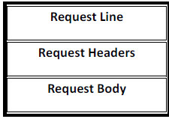

**Request Line**:

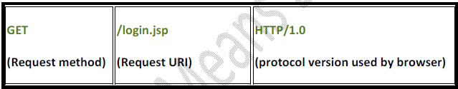

**Request Headers**:

**The request headers describes configuration information of the browser like**

1. media types accepted by browser , language accepted by browser , encoding types supported by browser etc.

2. Web server use this information to send customized responses to the client.

**Request Body**:

1. It contains end-user provides information for the GET request it is optional where as for the POST request it is mandatory.

2. This is the structure of HttpRequest , If the browser sends request in this format , then only webserver understands the request . i.e, webserver understandable form.

**Structure of HttpResponse:**

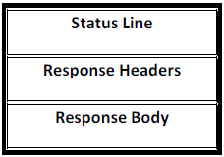

**Status Line :**

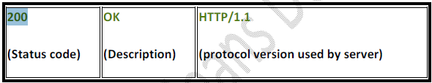

**Status Codes:**

*1xx --------> Informational*

*2xx--------->Successful*

*3xx--------->Redirectionaal*

*4xx--------->client error*

*5xx--------->Server error*

**Response Headers:**

These will provide configuration information of the server and information about the response [meta data] like content type of response , content length , last modified data etc.,

Browser will use these response headers to represent properly the response to the end-user.

**Response Body** :

It contains the original response provided by webserver.

If the server sends the response in the above form, then only browser understands the response i.e., it is browser understandable form.

**Types of HttpRequest methods:**

Based on type of information requested by the browser HttpRequest methods are divided as follows

**1. GET**

**2. POST**

**3. HEAD**

**4. OPTIONS**

**5. PUT**

**6. DELETE**

**7. TRACE**

**8. CONNECT**

**9. MOVE**

**10. LOCK**

**11. PROFIND**

1 - 3 methods introduced in http 1.0

4 - 11 methods introduced in http 1.1

1 - 7 are Big Http methods

**GET**:

1. We can use get request if we are expecting information from the server.

2. Usually for the get request read operation will be performed at server side. Hence status of application won't be changed in get request.

3. In GET request end-users provided information will be appended to the url as the part of Query string.

4. As the end-users information is visible in url. There may be a chance of security problems will raise. Hence sensitive data we can't send by using get request.

5. The length of the url is fixed. Hence we can send only limited amount of information by get request .

6. Only character data is allowed in url. Hence we can't send binary data by using get request.

7. As extra client provided information is available in the url, Bookmarking of url is possible .

**Idempotent request** :

By repeating the request multiple times , if there is no change in response such type of requests are Idempotent requests.

**Ex**: GET requests are Idempotent and POST requests are not Idempotent.

**Safe request:**

By repeating the same request multiple times, if there is no side-effect at server side, such type of requests are called safe-requests .

**Ex**: GET requests are safe, whereas POST requests are not safe to repeat.

**Triggers to send GET request:**

1) Type url in the address bar and submit is always GET request.

2) Clicking hyperlink is always GET request.

3) Submitting the form, where method attribute specify with GET value is always GET request.

*<form action="/test" method="GET">*

*----------- ----*

*</form>*

4) Submitting the form without method attribute is always GET request i.e., default method for form is GET.

*<form action="/test">*

*----------*

*---------*

*</form>*

**POST:**

1. If we want to post huge amount of information to the server then we should go for POST.

**Ex:** uploading our resume in job portal.

2. Usually in post requests update operation will be performed. The state of operation will be changed.

3. In post request, client information will be encapsulated in the request body instead of appending to the url. Hence we can send sensitive data by using POST request.

4. There is no limit on size of request body. Hence we can send huge amount of information to the Server.

5. We can send binary data also in addition to text data.

6. Bookmarking of POST request is not possible.

7. POST requests are not Idempotent and not-safe to repeat.

**Triggers to send POST request :**

There is only one-way to send POST request that is to use the form with method attribute value is POST.

*<form action="/test" method="POST">*

*----------*

*---------*

*</form>*

I.e., without having the form there is no chance of sending POST request.

**Differences between GET & POST :**

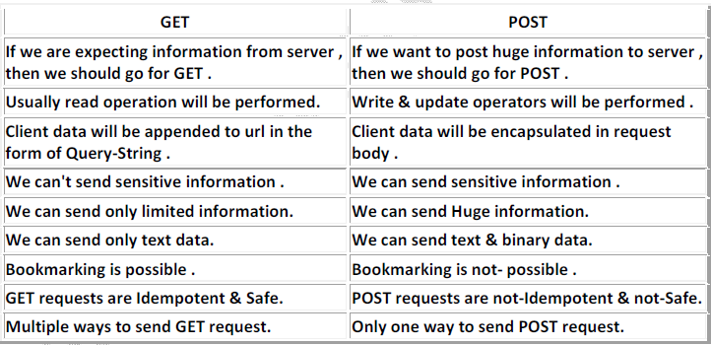

**HEAD**:

* We can use this method to get only response header information like content type, content length, last modified date etc., but no response body i.e., head request retrieves always response header but not response body.
* For HEAD request, internally doGet( ) will be executed. HEAD request is part of GET request.
* HEAD requests are Idempotent & Safe.

*HEAD request -----> doHead {*

*doGet {*

*take only header part of GET response and*

*provide that as response to HEAD request.*

*}*

*}*

**OPTIONS :**

* This method is for getting supporting http methods to retrive a perticular resource from the Server side.
* OPTIONS method is Idempotent and Safe.

**Note**: HEAD response is the part of GET response and OPTIONS is the part of HEAD response.

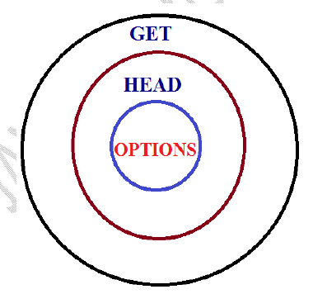

**response from OPTIONS method request** :

*Http 1.1 | 200 | OK*

***Host****: www.jobs4times.com*

***Server****: Apache*

***Date****: Fri, o8 Nov*

***Allow****: OPTIONS , HEAD , GET , POST*

***Content length****: 0*

**PUT** :

1. We can use PUT method for placing a resource at Server side where the location is specified by URL.

2. At the specified location, if already another resource present then the old resource is replaced with provided new resource.

3. By means of status code we can identify whether replacement is happened or not.

4. 200 means replacement happens, 201 means replacement not happen.

5. PUT method is Idempotent but not Safe.

**DELETE**:

* We can use this method for deleting a particular resource from Server side. It is exactly counter part of PUT method.
* DELETE is Idempotent, but not-Safe.

**Note**: As the PUT & DELETE methods are not safe. Most of the web-servers won't allow these methods by default.

To allow these methods at server side some configuration changes are required.

**TRACE**:

We can use this method for debugging purposes. If we want to know what request, server getting exactly as response, then we should go for TRACE method.

TRACE method is Idempotent and Safe.

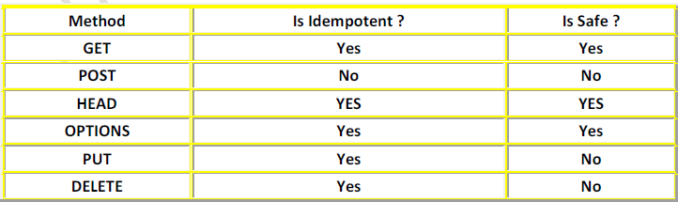



**Note** : The only non-idempotent method is POST .

**The following methods are not safe:** POST, PUT , DELETE.

**HttpServlet** :

We can use HttpServlet class as a base class to develop Http based Servlets.

It is the child class of GenericServlet.

For every Http method XXX , HttpServlet class contains the corresponding doXxx() methods.

|  |
| --- |
| protected void doXxx() throws ServletException, IOException |

**Ex**:

protected void doGet(HttpServletRequest request , HttpServletResponse response ) throws ServletException, IOException

doGet( ), doPost( ), doHead( ), doOption( ), doPut( ), doDelete( ),doTrace( ).

**HttpServlet contains 2 service( ) methods.**

1. public void service(ServletRequest request , ServletResponse response ) throws ServletException, IOException
2. protected void service(HttpServletRequest request , HttpServletResponse response ) throws ServletException, IOException

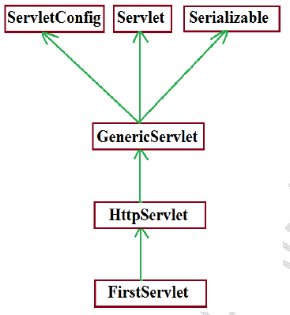

**Ex: Demo program for HttpServlet**.

**login.html**

*We can use this to send post request to the server*

*<html>*

*<body><h1>This is HttpServlet Demo</h1>*

*<form action="/scwcd1c/test" method="post">*

*Enter Name : <input type="text" name="uname" >*

*<input type="submit">*

*</form>*

*</body>*

*</html>*

**FirstServlet.java**

*import javax.servlet.*;*

*import javax.servlet.http.*;*

*import java.io.*;*

*public class FirstServlet extends HttpServlet {*

*public void doGet(HttpServletRequest request, HttpServletResponse response) throws ServletException, IOException {*

*PrintWriter out=response.getWriter();*

*String name=req.getParameter("uname");*

*out.println("Hello"+name+"Good Morning , This is doGet method");*

*}*

*public void doPost(HttpServletRequest request, HttpServletResponse response) throws ServletException, IOException {*

*PrintWriter out=response.getWriter();*

*String name=req.getParameter("uname");*

*out.println("Hello"+name+"Good Morning , This is doPost method");*

*}*

*}*

**web.xml**

*<web-app>*

*<servlet>*

*<servlet-name>first</servlet-name>*

*<servlet-class>FirstServlet</servlet-class>*

*</servlet>*

*<servlet-mapping>*

*<servlet-name>first</servlet-name>*

*<url-pattern>/fs</url-pattern>*

*</servlet-mapping>*

*</web-app>*

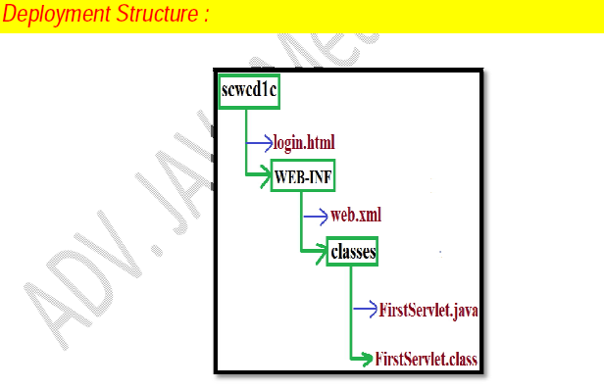

**Life Cycle of HttpRequst:**

1) Whenever we are submitting the form , browser prepares HttpRequest and send to the Server.

2) Webserver checks whether the request is for static or for dynamic information, by using URL.

3) If the request is for static information, webserver provide required response.

4) If the request is for dynamic information, then webserver forwards that request to web-container.

5) Webcontainer identifies the corresponding matched servlet by using web.xml

6) Webcontainer checks whether the corresponding Servlet object is already available or not. If it is not already available, then webcontainer loads the corresponding .class file and perform instantiation by executing public no argument constructor.

7) After instantiation, immediately webcontainer creates the ServletConfig object and invoke init( ) by passing that config object as argument.

8) Webcontainer creates ServletRequest and ServletResponse object and by passing those as arguments, It will invoke public service ( ).

9) With in that service ( ) , request and response objects will be type casted into

HttpServletRequest and HttpServletResponse and invoke protected service ( ) by passing those as arguments.

*public void service(ServletRequest req , ServletResponse res ) throws ServletException, IOException {*

*HttpServletRequest req=(HttpServletRequest)req ;*

*HttpServletResponse res=(HttpServletResponse)res ;*

*service (req1 , res1);*

*}*

10) With in the protected service ( ) we will identify HttpRequest method and

corresponding doXxx( ) will be invoked. If it is not a valid Http method then it is method will return 501 status code response saying invalid Http method .

*protected void service(HttpServletRequest request,HttpServletResponse response) throws ServletException, IOException{*

*String method=request.getMethod( ) ;*

*if(method.equals("GET")) {*

*doGet(req , res) ;*

*}*

*else if(method.equals("POST")) {*

*doPost(req , res) ;*

*}*

*else if(method.equals("HEAD")) {*

*doHead(req , res) ;*

*}*

*..........................*

*.........................*

*else {*

*prepare response with 501 Status code saying Invalid Http Method.*

*}*

*}*

11) If our Servlet class contain required doXxx( ) , then it will be executed . Otherwise parent class doXxx( ) will be executed.

**NOTE:**

1. For every web application, web container creates one ServletContext object at the time of application deployment.

2. For every Servlet, web container creates one ServletConfig object just before calling init( ).

3. For every request web container creates one ServletRequest and one ServletResponse objects just before calling service( ) . Once service( ) completes both request and response objects will be eligible for Garbage Collector(GC).

***Case 1:***

If we are writting public service( ) in our Servlet , then for any type of request [GET or POST] only service( ) will be executed.

***Case 2 :***

If our Servlet contains both public service( ) and protected service( ) , then for every request only public service( ) will be executed.

**Case 3 :**

If our Servlet contains both service( ) and doGet( ) , then for any request including GET, only service( ) will be executed. And there is no chance of executing doGet( ).

**Note**: It is never recommended to place service( ) in our Servlet. i.e., defining service( ) in our Servlet is stupid kind of activity.

***Case 4 :***

If we are sending get request , but our Servlet doesn't contain doGet( ) , then HttpServlet doGet( ) will be executed which provides response with 405 status code saying Http method GET is not Supported by this url.

***Case 5 :***

If we are sending post request , but our servlet doesn't contain doPost( ) , then HttpServlet doPost( ) will be executed , which provide 405 status code saying Http method POST is not Supported by this url.

***Case 6 :***

HttpServlet class doesn't contain any abstract method, still it is declared as abstract class what is the reason?

For majority methods in HttpServlet, proper implementation is not available and these are just to send error information.

Hence if we are creating HttpServlet object directly and calling these methods , we will get just error information, with that we can't do anything.

To prevent instantiation of HttpServlet, Sun people declared HttpServlet class as abstract .

***Case 7 :***

To provide same response for both GET and POST request , we have to implement doGet( ) and doPost( ) as follows .

**Ex**:

*public class FirstServlet extends HttpServlet {*

*public void doGet(HttpServletRequest request,HttpServletResponse response) throws ServletException, IOException {*

***// implemented required information***

*}*

*public void doPost(HttpServletRequest request,HttpServletResponse response) throws ServletException, IOException {*

*doGet( ) ;*

*}*

*}*

***Case 8 :***

In our Servlet, It is not recommended to override the following methods. Because these methods are properly implemented inside HttpServlet.

*1. service(ServletRequest request, ServletResponse response)*

*2. service(HttpServletRequest request, HttpServletResponse response)*

*3. doHead( )*

*4. doOptions( )*

*5. doTrace( )*

***Case 9 :***

In our Servlet, it is highly recommended to override the following methods, because these methods doesn't have proper implementation in HttpServlet.

*6. doGet( )*

*7. doPost( )*

*8. doPut( )*

*9. doDelete( )*

***Case 10 :***

To provide response to HEAD request , we have to override either doHead( ) or doGet( ) , otherwise we will get 405 status code saying Http method GET is not supported by this url.

**HttpServletRequest :(I)**

Using HttpServletRequest, write code to

1. **Retrieve Form parameters**

*1. getParameter( )*

*2. getParameterValues( )*

*3. getParameterNames( )*

*4. getParameterMap( )*

2. **Retrieve request Headers**

*1. getHeader( )*

*2. getHeaders( )*

*3. getHeaderNames( )*

*4. getIntHeader( )*

*5. getDateHeader( )*

3. **Retrive Cookies**

*1. getCookies( )*

**Retrieve Form parameters :**

* Form parameters are key-value pairs , where both key and values are String objects only.
* A parameter can be associated with either a single value or with multiple values.
* ServletRequest interface defines the following methods to retrieve Form parameters at server side.

*1. getParameter( )*

*2. getParameterValues( )*

*3. getParameterNames( )*

*4. getParameterMap( )*

1. **getParameter**( ) :

|  |
| --- |
| public String getParameter(String pname ) |

* It returns the value associated with specified parameter.
* If the parameter associated with multiple values then this method simply returns only first value.
* If the specified parameter not available then we will get null argument is case sensitive.

|  |
| --- |
| String user=request.getParameter("uname"); |

2. **getParameterValues**( )

|  |
| --- |
| public String[ ] getParameterValues(String pname ) |

* It returns all values associated with specified parameter.
* If the parameters not available, we will get null.
* Argument is Case-Sensitive.

**Ex:**

*String[] course=request.getParameterValues("course");*

*for(String s:course) {*

*out.println(s);*

*}*

3. **getParameterNames**( )

|  |
| --- |
| public Enumeration getParameterNames( ) |

* Returns all Form parameters names.
* If the request is not associated with any form parameters. Then we will get empty enumeration object but not null.

**Ex**:

*Enumeration e= request.getParameterNames( ) ;*

*while(e.hasMoreElements( ) {*

*String pname=(String)e.nextElement( ) ;*

*String pvalue=request.getParameter(pname);*

*out.println(pname+" "+pvalue);*

*}*

4. **getParameterMap**( )

|  |
| --- |
| public Map getParameterMap( ) |

* Returns the map object containing parameter names as keys and parameter values as map values.
* Keys are strings and values are string[ ] .
* If the request doesn't associated with any parameters , this method returns empty map object , but not null.

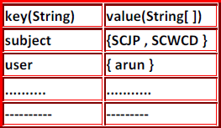

**Ex**:

*Map m = request.getParameterMap( ) ;*

*for(Object o : m) {*

*Map.Entry m1=(Map.Entry) o;*

*String pname=(String)m1.getKey( );*

*String[ ] pvalue=(String[])m1.getValue() ;*

*out.print(pname+"......." );*

*for( String s1 : pvalue ) {*

*out.println(s1 + " , ");*

*}*

*out.println(" ");*

*}*

***output*** *:*

*subject .....SCJP , SCWCD*

*user.......arun*

**Example** :

*Map m=req.getParameterMap();*

*Set keySet=m.entrySet();*

*Iterator itr=keySet.iterator();*

*while(itr.hasNext()) {*

*Map.Entry entry=(Map.Entry)itr.next();*

*String pname=(String)entry.getKey();*

*out.println(pname);*

*String[] pvalues=(String[])entry.getValue();*

*out.println(pvalues);*

**Example** :

*public void doPost(..).. {*

*response.setContentType();*

*PrintWriter pw=res.getWriter();*

*out.println("");*

*out.println("name :"+ request.getparameter("uname"));*

*............*

*............*

*}*

**Retrieving Request headers**:

* For every request browser sends its configuration information in the form of request headers. These may include the media types accepted by browser , encoding types supported by browser the type of browser etc.
* Server uses these request headers to send customized responses to the client.

***The following are some of the important request headers.***

1) **Accept :**

Media types accepted by browser.[ like txt/html , pdf , ppt , jar ]

2) **Accept-Encoding**:

Encoding types supported by browser.

3) **User-agent**:

It represents the type of the browser.

4) **Content-length:**

It represents the length of request body.

5) **Cookie :**

Used to send cookies for Session management.

***Utilities of Request headers:***

1. By using Accept-Encoding request header at Server side we can identity whether browser supports compression from or not.

2. If browser supports compressed form , we can send response in compressed form. So that we can save download time and bandwidth.

3. By using User-agent request header at server side we can identify the type of browser which sends the request. Based on that we can send browser compatable customized responses.

4. By using Cookie request header we can send Cookie to the server so that we can achieve session management.

**HttpServletRequest defines the following methods to retrieving header information at server side**

1. **getHeader**( )

|  |
| --- |
| public String getHeader(String hname) |

* It returns the value associated with specified request header.
* If the header associated with multiple values then this method returns only 1st value.
* If the specified request header is not available then we will get null.
* Argument is not-case sensitive .

**Ex**:

String hvalue=request.getHeader("accept");

**output:**

accept -- text/html , application/xhtml+xml , application/xml ;

2. **getHeaders**( )

|  |
| --- |
| public Enumeration getHeaders(String hname) |

* Returns all values associated with specified header.
* If the specified header not available, then this method returns empty Enumeration object, but not null.
* Argument is not-case sensitive.

3. **getHeaderNames**( )

|  |
| --- |
| public Enumeration getHeaderNames( ) |

* Returns all request header names associated with that request object.
* HttpServletRequest defines the following more convenient methods to retrieve int and date values(Headers) directly.

4. **getIntHeader**( )

|  |
| --- |
| public int getIntHeader(String hname); |

**Ex**:

*String length=request.getIntHeader("content-length");*

*int l=Integer.parseInt(length);*

*(****OR****)*

*int l=request.getIntHeader("content-length");*

If the specified request header is not associated with int value , then this method

returns NumberFormatException.

req.getIntHeader("user-agent");//**RE:java.lang.NumberFormatException**

If the specified request header is not available in getIntHeader() , this method returns "-1" but not null.

5. **getDateHeader**( )

|  |
| --- |
| public long getDateHeader(String hname); |

* Returns the date value associated with specified header as no. of milliseconds Since Jan 1st 1970.
* If we pass these milliseconds as arguments to Date constructor. We will get exact date

**Ex**:

*long l=request.getDateHeader("date");*

*Date d=new Date(l);*

* If the specified header is not associated with the date , then we will get RuntimeException saying IllegalArgument Exception.
* If the specified request header is not available in getDateHeader() , this method returns "-1" but not null.

***Write a Servlet to print all request-headers associated with the request.***

**Ex:**

*public class ReqHeader extends HttpServlet {*

*public void doGet(HttpServletRequest request,HttpServletResponse response) throws ServletException, IOException {*

*PrintWriter out = response.getWriter( ) ;*

*Enumeration e = request.getHeaderNames( ) ;*

*while(e.hasMoreElements( ) ) {*

*String hname=(String)e.nextElement( );*

*String hvalue=request.getHeader(hname);*

*out.println(hname+"------"+hvalue);*

*}*

*}*

*}*

**Retriving Cookies from the request**:

HttpServletRequest interface defines the following methods to retrive cookies from the request object.

**Cookie[] c = request.getCookiees( ) ;**

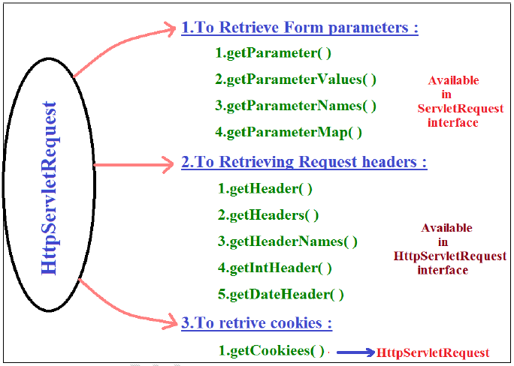

***Retrieving client & Server information from the request:***

ServletRequest interface defines the following methods to retrieve client and server information from request.

|  |
| --- |
| public String getRemoteHost( ) |

* Returns fully qualified name of the client which sends the request.

|  |
| --- |
| public String getRemoteAddr( ) |

* Returns IP-address of the client.

|  |
| --- |
| public String getRemotePort( ) |

* Returns the port no. on which the client is running.

|  |
| --- |
| public String getServerName( ) |

* Returns the name of the Server to which the request has been sent.

|  |
| --- |
| public String getServerPort( ) |

* Returns the port no. on which server is running.

A request triggered from www.jobs4times.com with an IP-address 192.168.203.32 running on port 1012. Place the appropriate ServletRequest methods to their corresponding values.

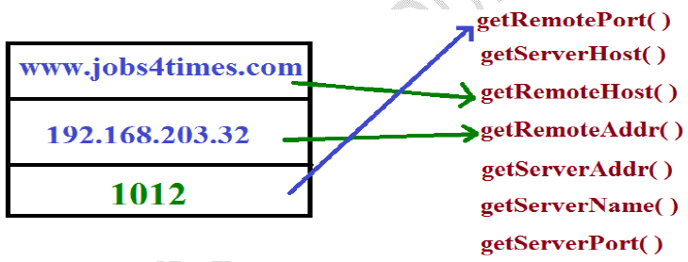

**HttpServletResponse**:

By using HttpServletResponse interface, write code

1. To set Response Headers .

2. To set content type of Response .

3. To acquire text stream for response.

4. To acquire binary stream for response .

5. To redirect the request to another URL .

6. To add cookies to response.

**Setting HttpResponse Headers**:

* Http response header describes the configuration information of the server and information about the response like content-type , content-length , last modified data etc.,
* Browser using these response headers to display response body properly to the end user.

**HttpServletResponse defines the following methods to add headers to the response**.

public void addHeader(String hname , String hvalue )

▪ If the specified header name is already available , to the existing values , this new

value will also be added.

▪ Replacement will not Occur .

public void setHeader(String hname , String hvalue )

▪ If the specified header is already available . Then the old value will be replaced with

new value .

Some times headers associated with int & date values .

1. public void addIntHeader(String hname , int hvalue )

2. public void setIntHeader(String hname , int value )

3. public void addDateHeader(String hname , long ms )

4. public void setDateHeader(String hname , long ms )

Note:

If the header associated with multiple values . Then we have to use addHeader( )

If the header associated with only one value , then we should go for setHeader( )

Set Content type of Response :

Content type header represents MIME type (multipurpose internet mail extension) of the

response.

Common MIME Types :

1. text/html --------> Html text as response

2. text/xml --------> xml document as response

3. image/jpeg --------> JPEG as response

4. image/png --------> png as response

5. application/ms-excel --------> excel sheet as response

6. application/ms-word --------> word document as response

7. application/pdf --------> PDF file as response

8. application/jar --------> jar file as response

We can set MIME type by using the following 2 ways

By ServletResponse interface :

It contains the following method to set the response.

public void setContentType(String mimeType)

Ex:

response.setContentType("application/PDF")

By HttpServletResponse interface :

It contains setHeader( ) to set content type.

public void setHeader(String hname , String hvalue)

Ex:

response.setHeader("content type" , "text/html");

Note: In general response.setContentType( ) is recommended to use.

To acquire text stream for the response :

1. We can send text data as the response by using PrintWriter object .

2. We can get PrintWriter object by using getWriter( ) of ServletResponse .

public PrintWriter getWriter( ) throws IOException

Ex:

PrintWriter out = response.getWriter( ) ;

To acquire Binary stream as response :

1. We can send Binary information(video , image files) by using ServletOutputStream object.

2. By using getOutputStream( ) of ServletResponse we can get this object .

public ServletOutputStream getOutputStream( ) throws IOException

Ex:

ServletOutputStream sos=response.getOutputStream ( ) ;

Demo program to send image file as response to the client

1) import javax.servlet.*;

2) import javax.servlet.http.*;

3)

4) public class BinaryStream extends HttpServlet {

5) public void doGet(HttpServletRequest request,HttpServletResponse response)

6) throws ServletException,IOException{

7) response.getContentType("image/jpeg");

8) ServletOutputStream sos = response.getOutputStream( ) ;

9)

10) //File f= new File("c:\\tomcat\sunset.jpeg");

11)

12) String path=getServletContext( ).getRealPath("sunset.jpeg");

13) File f= new File(path);

14) FileInputStream fis=new FileInputStream(f);

15)

16) byte[] b=new byte[(int)f.length()];

17) //f.length() returns long so we have to convert into int.

18) //[] --> accepts int only

19)

20)

21) fis.read(b); //reading the image & place into byte[]

22) sos.write(b); //write byte[] to response

23) sos.flush( );

24) sos.close( );

25) }

26) }

To send XML data as a response :

1) response.setHeader("content-Type","text/xml");

2) PrintWriter out=response.getWriter();

3) out.print("<?xml version=\"1.0\"?>");

4) out.print("<greeting language=\"en_US\">");

5) out.print("hello world");

6) out.print("</greeting>");

Note :

At any point of time we can get either PrintWriter object (or) ServletOutputSteram object but

not both , simultaneously.

Otherwise we will get RuntimeException saying IllegalStateException

Because from the Servlet we can send only one response at a time.

1) public void doGet( ) {

2) PrintWriter out=response.getWriter( );

3) ServletOutputStream sos =response.getOutputStream( ) ;

4) -----------

5) -----------

6) }

Output: RuntimeException saying IllegalStateException getWriter( ) has already been called

for this response.

IIQ: By using which of the following stream we can send both binary & text data as response

from the Servlet ?

1. PrintWriter( )

2. ServletOutputStream ( )

3. ServletInputStream ( )

4. None of the above ( )

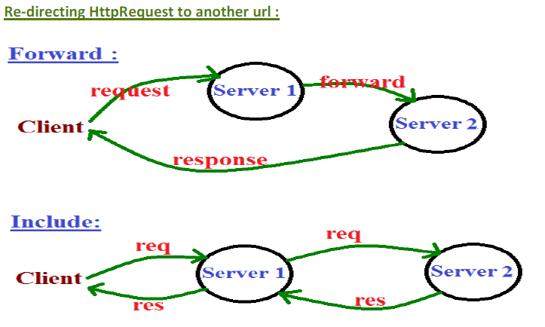

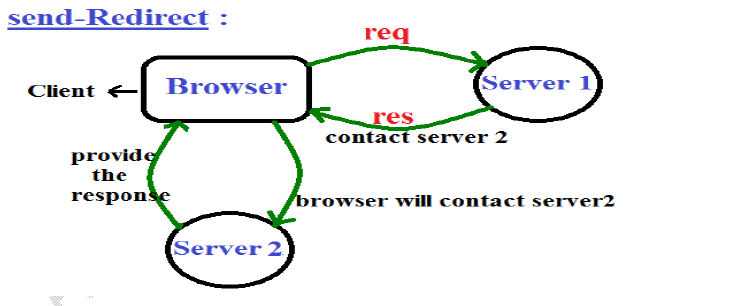

Forward & include should work when both servlets should be in same server .

Some times we have to re-direct the request to another url we can achieve this by using

sendRedirect( ) of HttpServletResponse .

public void sendRedirect(String targetpath) throws IOException

Process of send Redirection :

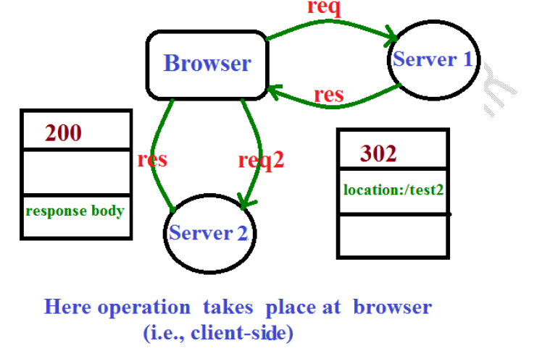

1. Browser sends request to Servlet1

2. If servlet1 is not responsible to provide response , then it will update browser to contact

servlet2. This can be informed by setting status code 302 & location header with servlet2.

3. Browser by seeing status code 302 creates a new request object & sends to Servlet2.

4. Servlet2 provides desired response to the browser & the browser inturn display that

response to the end user .

Demo program for send Re-direct :

1) public class FirstServlet extends HttpServlet {

2) public void doGet(HttpServletRequest request,HttpServletResponse response)

3) throws ServletException, IOException {

4) response.sendRedirect("test2");

5) (or)

6) response.setStatus("302");

7) response.setHeader("location" , "scwcd/test2");

8) }

9) }

1) public class SecondServlet extends HttpServlet {

2) public void doGet(HttpServletRequest request,HttpServletResponse response)

3) throws ServletException, IOException {

4) PrintWriter out=response.getWriter( );

5) out.println("2nd Servlet ");

6) }

7) }

▪ When ever we are sending request to FirstServlet , SecondServlet will provide the

response through re-direction

▪ After committing the response we are not allow to perform re-direction. Otherwise we

will get RuntimeException saying IllegalStateException(Tomcat people doesn't provide

support for this).

1) public void doGet(HttpServletRequest request,HttpServletResponse response)

2) throws ServletException, IOException {

3) -----------------

4) ---------------------

5) out.flush(); //committing the response

6) response.sendRedirect("/test2"); //RE:IllegalStateException

7) }

Applicable for forward also.

Differences between send-Redirection and forward mechanism :

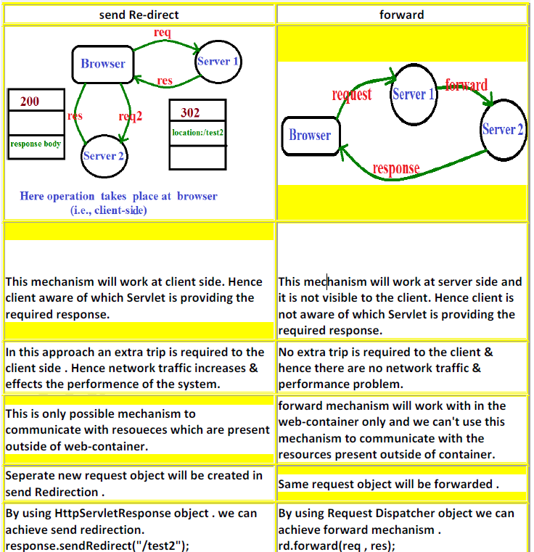

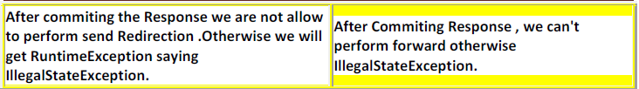

Adding Cookies to the response :

HttpServletResponse contains the following method to addCookie to the Response object.

public void addCookie(Cookie c )

Ex:

Cookie c=new Cookie(String name , String value) ;

response.addCookie(c);

NOTE :

1. We can use redirection to communicate either with in the same server or outside the

server. But recommended to use communicate outside.

2. forward mechanism is applicable to communicate only with in the same server . But

outside of server we can't use.

3. To communicate with in the same server we can use either forward or send

redirection but recommended to use forward.

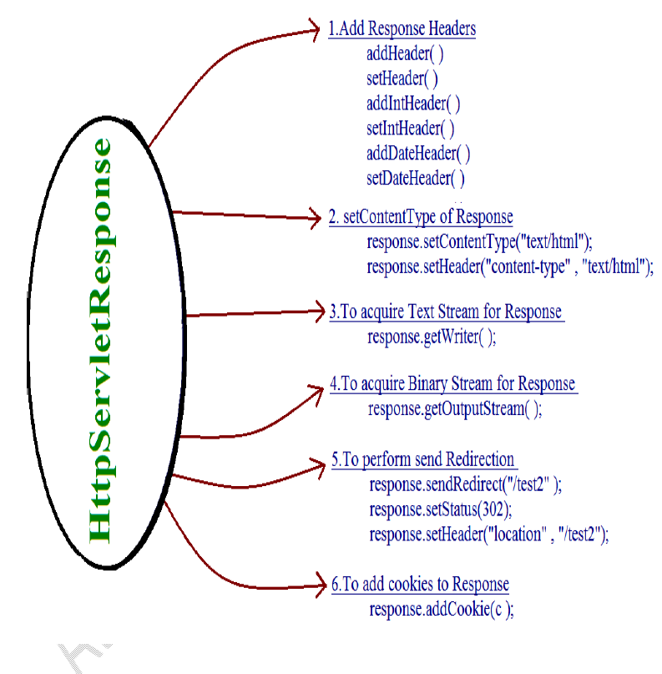

In web applications, with http protocol we are able to specify different types of requests at client browser. The above flexibility is possible for the http protocol due to the availability of 7 number of http methods called as BIG 7 http methods.

Http protocol has provided the following http methods along with http1.0 version.

1. GET

2. POST

3. HEAD

Http protocol has provided the following http methods as per http1.1 version.

1. OPTIONS

2. PUT

3. TRACE

4. DELETE

Http1.1 version has provided a reserved http method i.e. CONNECT.

Q: What are the differences between GET and POST methods?

or

What are the differences between doGet(_,_) and doPost(_,_) methods?

Ans:   
  
1. GET request type is default re quest type in web applications, but POST request type is not default request type.

2. GET request type should not have body part in the request format, but POST request type should have body part in the request format.

3. If we specify request parameters along with GET request then that request parameters will be transferred to server through request format header part due to the lack of body part.

In general request format header part will have memory limitation so that it is able to carry maximum 256 no. of characters. Therefore, GET request is able to carry less data from client to server

Due to the availability of body part in POST request all the request parameters will be transferred to server through request format body part, here there is no memory limitation in request format body part so that the POST request is able to carry large data from client to server.

4. If we specify request parameters along with GET request then GET request will display all the request parameters at client address bar as query string. Therefore, GET request is able to provide less security for the client data.

If we provide request parameters along with POST request then GET request will not display the request parameters at client address bar. Therefore, POST request is able to provide very good security for the client data.

5. In general in web applications, GET request can be used to get the data from server i.e. download the data from server.

In general in web applications, POST request can be used to post the data to server i.e. upload the data on to the server.

Note:   
Bookmarks are supported by GET request and which are not supported by POST request.

Q: What is the difference between GET request and HEAD request?

Ans:

If we send Get request for a particular resource available at server machine then server will send only the requested resource as a response to client.

If we send HEAD request for a particular resource available at server then server will send requested resource as well as the metadata about the requested resource as response.

Note:   
Internally HEAD request uses GET request to get the requested resource from server.

OPTIONS Request:

The main purpose of the OPTIONS request type is to get the http methods which are supported by the present server.

Note: In general http protocol has provided by 7 http methods conceptually, supporting all the methods or some of the methods or none is completely depending on the server implementation provided by the server providers.

With this convention we are unable to credit how many number of http methods are supported by the present application server, where to credit the http methods which are supported by the present server we have to use OPTIONS request type.

Q: What is the difference between POST request and PUT request?

Ans:   
  
Both POST request and PUT request can be used to upload the data on the server machine. To upload the data on server machine if we use POST request then it is not mandatory to specify particular address location along with POST request.

To upload the data on server machine if we use PUT request then it is mandatory to specify server side location along with PUT request.

TRACE Request:

The main purpose of the TRACE request is to get the working status of a particular resource available at the server machine. TRACE request type is able to execute its functionality like echo server.

DELETE Request:

The main purpose of this request type is to delete a particular resource available at server machine.

Note: Almost all the servers may not support PUT, DELETE and request types as per their security constraints. In general almost all the servers are able to support GET and POST request types.

Second Approach to Design Servlets (Extendiging

GenericServlet abstract class):

If we want to design servlets by using this approach then we have to take an user defined

class which must be a subclass to GenericServlet abstract class.

public abstract class GenericServlet implements Servlet, ServletConfig, Serializable {

private transient ServletConfig config;

public void init(ServletConfig config)throws ServletException {

this,config=config;

init();

}

public void init()

{ }

public abstract void service(ServletRequest req, ServletResponse res)throws SE, IOE;

public ServletConfig getServletConfig() {

return config;

}

public String getServletInfo() {

return null;

}

public void destroy() { }

}

public class MyServlet extends GenericServlet

{ -------

------- }

From the above predefined implementation of GenericServlet abstract class,

1. GenericServlet is an idea came from Adapter Design Pattern.

2. GenericServlet predefined abstract class has implemented Serializable interface so

that all the GenericServlet objects(subclass objects of GenericServlet abstract

class) are eligible for Serialization and Deserialization by default.

3. It is possible to serialize GenericServlet objects, but config predefined reference

variable will not be participated in serialization and deserialization because config

reference variable has declared as transient.

4. In GenericServlet abstract class, init(_) method is overloaded method.

5. In GenericServlet abstract class, still service(_,_) method is an abstract method.

Q: What is the requirement to override init(_,_) method in servlet applications?

Ans: In general as part of servlets design we will use service(_,_) method to provide

application logic. In some cases, application logic may include the actual business logic and

its prerequirement.

If we provide both prerequirement code and business logic within service(_,_) method

then the performance of the application will be reduced because container will execute

business logic and its prerequirement code for every request send by the client, but as per

the convention it is sufficient to execute prerequirement code only one time.

In the above context, to improve the performance of servlet applicationwe have to

provide the actual business logic in service(_,_) method and the prerequirement code in

init(_) method because container will execute init(_) method only one time, but service(_,_)

method for every request.

Note: In servlet applications, always it is suggestible to override init() method(second init()

method) but if our prerequirement code may include any dat from ServletConfig object then

it is suggestible to override init(ServletConfig config) method.

--------------Application by using GenericServlet---------------

Genericservletapp:-

web.xml:-

<web-app>

<servlet>

<servlet-name>GenericDemo</servlet-name>

<servlet-class>GenericDemo</servlet-class>

</servlet>

<servlet-mapping>

<servlet-name>GenericDemo</servlet-name>

<url-pattern>/gen</url-pattern>

</servlet-mapping>

</web-app>

GenericDemo.java:-

import java.io.IOException;

import java.io.PrintWriter;

import javax.servlet.GenericServlet;

import javax.servlet.ServletException;

import javax.servlet.ServletRequest;

import javax.servlet.ServletResponse;

public class GenericDemo extends GenericServlet {

public void service(ServletRequest request, ServletResponse response) throws

ServletException, IOException {

response.setContentType("text/html");

PrintWriter out=response.getWriter();

out.println("<h1><center>hello</center></h1>");

}

}

The main difference between first approach and second approach of designing servlets in

the point of flow of execution, in first approach container will execute only one init(_)

method in servlet initialization, but in second approach container will execute two init()

methods in servlet initialization.

Third Approach to Design Servlets (Extendiging

HttpServlet abstract class):

Q: Whar are the differences between GenericServlet and HttpServlet?

Ans: 1. GenericServlet is protocol independent, but HttpServlet is http protocol dependent.

2. In case of GenericServlet, container will execute only service(_,_) method for any type of

protocol request provided by the client, but In case of HttpServlet, container will execute a

separate method on the basis request type which will be specified by the client.

Ex: If we specify Get request type at client browser then HttpServlet is able to execute

doGet(_,_) method, for POST request type HttpServlet will execute doGet(_,_) method.

3. GenericServlet is not very good compatible with protocols, but HttpServlet is very good

compatible with http protocol.

4. GenericServlet will not implement any specific protocol at server side, but HttpServlet has

implemented http protocol at server side.

5. GenericServlet will not give any option to the developers to specify different types of

requests at client browser, but HttpServlet will provide flexibility to the developers to specify

different types of requests at client browser.

If we want to prepare servlets by using HttpServlet abstract class then we have to take

an user defined class which must be a subclass to HttpServlet abstract class.

public abstract class HttpServlet extends GenericServlet {

public void service(ServletRequest req, ServletResponse res)throws SE, IOException {

HttpServletRequest hreq=(HttpServletRequest)req;

HttpServletResponse hres=(HttpServletResponse)res;

service(hreq, hres);

}

public void service(HttpServletRequest hreq, HttpServletResponse hres)throws SE, IOE {

String method=hreq.getMethod();

if(method.equals("GET")) {

doGet(hreq, hres);

}

if(method.equals("POST")) {

doPost(hreq, hres);

}

}

public void doGet(HttpServletRequest hreq, HttpServletResponse hres)throws SE, IOE

{ }

public void doPost(HttpServletRequest hreq, HttpServletResponse hres)throws SE, IOE

{ }

}

public class MyServlet extends HttpServlet

{ ------

------ }

Note: In case of HttpServlet, we have to override either doGet(_,_) method or doPodt(_,_)

method and son on doXxx(_,_) method with our web application logic on the basis of

request type which we provide at client browser.

--------------Application by using HttpServlet---------------

httpservletapp:-

web.xml:-

<web-app>

<servlet>

<servlet-name>HttpDemo</servlet-name>

<servlet-class>HttpDemo</servlet-class>

</servlet>

<servlet-mapping>

<servlet-name>HttpDemo</servlet-name>

<url-pattern>/http</url-pattern>

</servlet-mapping>

</web-app>

HttpDemo.java:-

import java.io.IOException;

import java.io.PrintWriter;

import javax.servlet.ServletException;

import javax.servlet.http.HttpServlet;

import javax.servlet.http.HttpServletRequest;

import javax.servlet.http.HttpServletResponse;

public class HttpDemo extends HttpServlet {

public HttpDemo() {

}

protected void doGet(HttpServletRequest request, HttpServletResponse response)

throws ServletException, IOException {

response.setContentType("text/html");

PrintWriter out=response.getWriter();

out.println("<h1>hello this is http</h1>");

}

}

The main difference between GenericServlet flow of execution and HttpServlet flow of

execution is in GenericServlet flow of execution container will execute only one service(_,_)

method to process the request, but in case of HttpServlet container will execute

service(ServletRequest, Servletresponse), service(HttpServletRequest,

HttpServletresponse), doXxx(HttpServletRequest, HttpServletresponse) on the basis of

request type in order to process the request.

Q: Is it possible to override service(_,_) method in HttpServlet?

Ans: In HttpServlet, it is possible to override any of the service(_,_) methods, doXxx(_,_)

methods, but always it is suggestible to override doXxx(_,_) methods on the basis of

request types, it is not at all suggestible to override service_,_) methods.

If we override service(_,_) method in HttpServlet then container will execute user

provided service(_,_) method, but container is unable to execute predefined service(_,_)

method so that it is not possible to reach doGet(_,_) method or doPost(_,_) method and so

on.

Q: Is it possible provide both constructor and init() method in a single servlet?

Ans: Yes, it is possible provide both constructor and init() method in a single servlet.

If we provide a static block, a constructor, init(_) method, doXxx(_,_) method and

destroy()method within a single servlet then container will execute static block at the time

of servlet loading, constructor at the time of servlet instantiation, init() method at the time

of performing servlet initialization, doXxx(_,_) method at the time of request processing and

destroy() method at the time of servlet deinstantiation.

Ex: public class MyServlet extends HttpServlet {

static {

System.out.println("Servlet Loading");

}

public MyServlet() {

System.out.println("Servlet Instantiation");

}

public void init() {

System.out.println("Servlet Initialization");

}

public void doGet(HttpServletRequest hreq, HttpServletResponse hres)throws SE, IOE {

System.out.println("Request Processing");

}

public void destroy() {

System.out.println("Servlet Deinstantiation");

}

}

If we send a request to above servlet then are able to see the following output on Server

prompt

Servlet Loading

Servlet Instantiation

Servlet Initialization

Request Processing

Servlet Deinstantiation (when we close the server).

If we want to provide any constructor in servlet class then that constructor should be

public and zero argument because container will search and execute public and zero

argument constructor as part of servlet instantiation to create servlet object.

If we provide parameterized constructor without zero-argument constructor then

container will raise an Exception like

javax.servlet.ServletException : Error-Instantiating Servlet class MyServlet with the root

case java.lang.InstantiationException:MyServlet.

